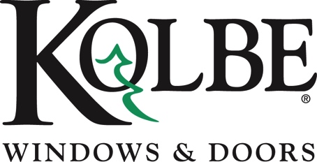

Kolbe will be exhibiting at the AIA Conference on Architecture in booth #4755
Media contacts: Heather West, 612-724-8760, heather@heatherwestpr.com
Cindy Bremer, 715-847-0570, cbremer@kolbe-kolbe.com

Kolbe’s Ultra Series inswing door unit makes a dramatic entrance

Wausau, Wisconsin (June 2018) – Kolbe Windows & Doors showcases its Ultra Series inswing door unit at the AIA Conference on Architecture in booth #4755. Highlighting design, customization options and finishing touches, this entrance door makes a strong first impression.

“A grand entrance adds distinction and creates impact. Our built-to-order entrance doors are designed to your specifications, offering numerous customization options for expressing your style and personality,” says Cindy Bremer, vice president of marketing at Kolbe Windows & Doors.

Kolbe’s Ultra Series inswing door is on display in booth #4755 in a two-panel configuration with an operable sidelite for a larger opening. Fire Engine Red panels highlight the exterior and are set off by a contrasting Coal Black flat casing. The interior of the White Oak door is stained Ebony to resemble barn boards.

“Whether you choose a traditional or a contemporary style, each of our entrance doors is unique. Personal marks of distinction include wood species, stain color and finish, shape and size, divided lites, specialty glass, hardware and functionality,” states Bremer.

The bold 8-foot-tall entryway features tempered Frosted Matte glass in the door panel and sidelite. A Dallas handle set in Satin Nickel PVD with a multi-point lock crisply completes the unit.

Bremer summarizes, “Kolbe knows the details make the difference. Our numerous options enable your individualized entryway to make a long-lasting impression.”

For complete information, specific product details, and data on Ultra Series inswing doors from Kolbe, please visit www.KolbeWindows.com or stop by booth #4755 at the 2018 AIA Conference on Architecture.

What began in 1946 as a two-brother team has grown into an internationally respected manufacturing company. Kolbe Windows & Doors is one of the nation’s leading manufacturers of windows and doors for residential and commercial markets. After more than 70 years, Kolbe products are best known for superior quality, custom craftsmanship, attention to detail, as well as innovative and unique designs.
###

