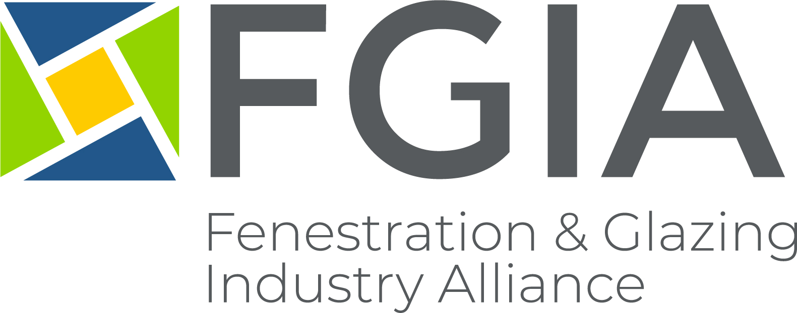

News Release
Media Contacts
Heather West, Heather West Public Relations
Email: heather@heatherwestpr.com; Phone: 612-724-8760

Angela Dickson, marketing and communications director, FGIA
Email: adickson@fgiaonline.org; Phone: 630-920-4999

Gina Gaudreault, MBA, Executive Vice President, AVFQ
Email: ggaudreault@avfq.ca; Phone: 418 569-6594

February 2, 2021

FGIA and AVFQ Finalize Collaboration Agreement
SCHAUMBURG, IL – An official agreement for collaboration between l’ Association de vitrerie et fenestration du Quebec (AVFQ) and the Fenestration and Glazing Industry Alliance (FGIA) has been finalized, allowing for the development of mutual synergies that will enable both organizations to best support their respective members. On December 17, 2020, the collaboration was formalized, enhancing the reach and visibility of both organizations while ensuring efficiencies in monitoring codes and regulatory affairs in Canada.
AVFQ and FGIA agreed to collaborate by sharing information and offering reciprocal benefits and services to members in the areas of education, advocacy, technical standards, research and product certification.
“This collaboration agreement will serve both AVFQ and FGIA members well in the future, working together to meet their mutual needs,” said Gina Gaudreault, MBA, Executive Vice President of AVFQ.
“Involvement in national Canadian codes and regulatory work is one of the core activities of FGIA that can also bring valuable information to AVFQ by making its members aware of the latest developments outside of the province of Quebec. In turn, AVFQ will provide information to FGIA regarding relevant developments within Quebec. Both organizations will communicate and, to the extent practical, coordinate public comments, which provides great value to both memberships and communicates strong industry collaboration and consensus,” said Janice Yglesias, FGIA Executive Director.
The agreement offers AVFQ members discounted rates to attend FGIA conferences held in Canada as well as virtual conferences. FGIA members may also attend AVFQ’s Annual Conference at the member discounted rate. Additionally, a small task group is being created to explore the possibility for AVFQ to use FGIA education content and adapt it to its audience as needed. AVFQ will also be invited to support FGIA research projects conducted with the objective of constantly improving the quality of products provided by the industry.
About AVFQ
AVFQ’s mission is to support, animate and represent the glazing and fenestration industry by stimulating the collective strength and collaborative culture of its members. Its vision is to be the essential group for the glazing and fenestration industry in Quebec. Their values include sharing, collaboration, integrity and respect.
More information about AVFQ and its activities can be found at avfq.ca.
About FGIA
FGIA is dedicated to improving home and building performance through better glass, window, door and skylight technology and standards. It is an inclusive community leading the glass and fenestration industry through research, consensus-based standards, product certification, advocacy and education and professional development.
More information about FGIA and its activities can be found at FGIAonline.org.

