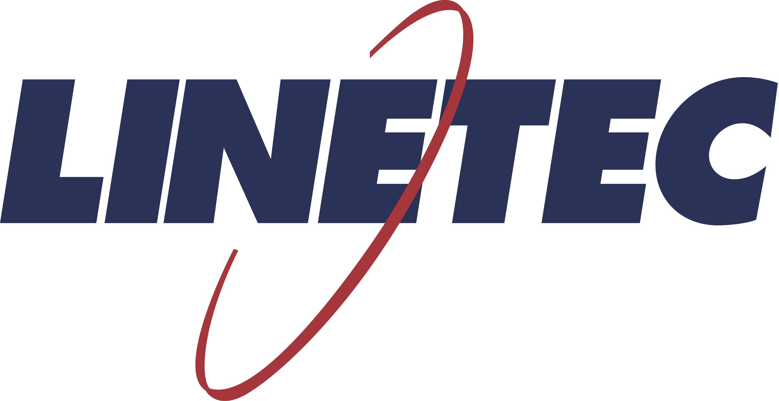
Media contact:
Heather West
612-724-8760
heather@heatherwestpr.com

Linetec’s Copper Anodize helps attract high-tech tenants
to three updated California office buildings

Wausau, Wisconsin (May 2020) – To attract and retain high-tech tenants to the Mountain View Corporate Center, the new owners invested in updating three buildings from concrete exteriors to a modern copper-colored metal panel façade. To achieve the intended appearance, Linetec finished more than 23,000 square feet of aluminum panels in its proprietary Copper Anodize. Along with the high-tech aesthetic, the durable anodize supports the property’s sustainability goals and protects the aluminum panels fabricated by Morin Corporation and installed by Sheet Metal Systems (SMS).

Originally built in the late 1980s as a corporate campus for a former single tenant, Rockwood Capital acquired the Mountain View Corporate Center’s 266,000-square-foot, five-building, 16-acre property in 2014. Recognized as a strong Silicon Valley submarket, the buildings now are home to multiple, high-tech tenants including Mozilla, a web software company, and Coursera, an ed-tech company.

Mountain View Corporate Center is one of the few large-scale office campuses in Silicon Valley where employees can walk or bike to Caltrain and retail amenities. The transit-oriented property is walking distance to downtown Mountain View’s Caltrain station and the Evelyn VTA light rail station, and provides direct access to the adjacent CA-237 freeway. Along with its convenient location, additional amenities include a large landscaped area for tenants to eat, play, and work outdoors; basketball and volleyball courts, showers, and easy access to the nearby Stevens Creek Trail.

Jason Oberman, director at Rockwood Capital, said, “A key foundation of our investment strategy is acquiring and enhancing properties in evolving locations which benefit from close proximity to public transit and surrounding mixed-use amenities. This comes from our belief that these well located properties can help support healthy living, a higher quality of life, and environmental sustainability.”

For more than 30 years, Linetec’s finishes have contributed to many sustainable projects and building renovations across the U.S. “Research shows that owners investing in façade improvements like these can benefit from lower vacancies, higher lease rates, and ultimately, an increase in their building’s overall value,” said Tammy Schroeder, Linetec’s marketing manager and LEED Green Associate.

“Elevating a property’s appearance with a new exterior not only is more attractive to prospective tenants, it helps existing tenants take a greater sense of pride in their workplace. Choosing durable anodize finishing also helps reduce maintenance and repair costs over a building’s lifetime,” she continued.

(more)

At Mountain View Corporate Center, three buildings were selected to benefit from a fresh look. Known by their addresses – 301, 321 and 351 E. Evelyn Ave. – all three were clad in Morin’s solid aluminum, corrugated panel and finished in Linetec’s Copper Anodize. On balconies and canopies for 301 and 321, the Copper Anodized panels also were perforated.

Linetec’s unique copper anodize finish maintains its initial copper color and does not patina over time. This proprietary and warrantied finish is accomplished through a three-step electrolytic coloring method, rather than the standard two-step process. The resulting finish remains a bright copper color, with no patina as it ages.

Copper Anodize from Linetec meets the industry-leading AAMA 611 Class I specification. Protecting and maintaining the structural integrity of the aluminum, it retains exceptional hardness and lasting durability. It does not require a clear coat or ongoing treatment to maintain color stability.

Anodized aluminum is an inert, non-combustible material that is 100% recyclable and poses no health risks. It resists the ravages of time, temperature, corrosion, humidity and warping, further contributing to the long life cycle and minimal maintenance for Mountain View Corporate Center’s buildings.

Complementing the metal cladding, an additional 5,400 square feet of Morin’s aluminum metal soffit panels were finished by Linetec in a Black Onyx color. Shielded from direct sunlight, but still finished to meet the highest AAMA 2605 industry standard, Linetec applied a 70% PVDF resin-based architectural coating on the soffits.

“The sheet metal and metal siding were a main component of turning this once all concrete tilt-up building into the unique office space it is today,” said Nick Hough, SMS president. Hough, who has more than 40 years of experience in the architectural sheet metal Industry, takes a hands-on approach to leadership and to supervising the SMS team.

Drawing from more than 15 years of experience in the architectural sheet metal industry, SMS foreman Hector Hernandez led the project’s six-person installation team. According to Hough, they worked up to six days per week and up to 10 hours per day to meet the demanding six-month project schedule for each building. The offices’ exterior enhancements were completed in 2019.

Working within the project’s schedule, SMS team coordinated shipping the aluminum panels from Morin in California to be finished at Linetec in Wisconsin, and then shipping the finished panels back the California project site. Working closely together to stay on time and within budget, Hough said, “Linetec saved our company 30% on transit costs by shipping the panels by train.”

In addition, Hough noted, “The weather became a challenge during these projects. When unexpected rain would not allow us to work onsite, we held progress meetings to discuss the safest and most efficient upcoming installation practices. …All trades were outstanding on this project and did a great job of keeping the job moving forward in a professional way.”

Learn more about joining Linetec’s architectural finishes and services by visiting https://linetec.com.

**

Mountain View Corporate Center, 301-381 E. Evelyn Ave., Mountain View, CA 94041
- Owner: Rockwood Capital, LLC; San Francisco; http://www.rockwoodcap.com
- General contractor: South Bay Construction; Campbell, California; https://www.sbci.com
- Metal panel system – fabricator: Morin Corporation, A Kingspan Group Company; Fontana, California; https://www.kingspan.com
- Metal panel system – installer: Sheet Metal Systems Inc.; Hollister, California; http://smsystemsinc.net
- Metal panel system – finisher: Linetec; Wausau, Wisconsin; https://linetec.com
- Before images: https://www.commercialcafe.com/commercial-property/us/ca/mountain-view/mountain-view-corporate-center
- Construction images: Sheet Metal Systems Inc.

About Linetec
Located in Wisconsin, Linetec serves customers across the country, finishing such products as aluminum windows, wall systems, doors, hardware and other architectural metal components, as well as automotive, marine and manufactured consumer goods. The company is a subsidiary of Apogee Enterprises, Inc. (NASDAQ: APOG).

Linetec is a member of the Aluminum Anodizers Council (AAC), the American Institute of Architects (AIA), the Association of Licensed Architects (ALA), the Fenestration & Glazing Industry Alliance (FGIA), the National Glass Association (NGA) and the U.S. Green Building Council (USGBC).
###

