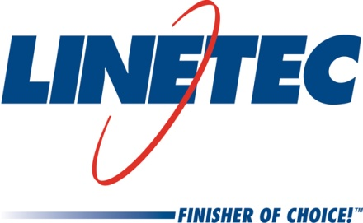
Media contacts:
Tammy Schroeder, 715-843-4100,
tammy.schroeder@linetec.com
and
Heather West, 612-724-8760,
heather@heatherwestpr.coms

Linetec wins Wisconsin Manufacturer of the Year Award

Wausau, Wisconsin (Feb. 23, 2018) – Linetec was honored to receive the Wisconsin Manufacturer of the Year Award in the “Large” category for companies with 300-799 employees. Winners were announced and presented at the 30th annual award program held in Milwaukee on Feb. 22. The award celebrates the successes of manufacturers in the state for their innovations, philanthropy, technological advances, commitment to customer satisfaction and quality jobs.

“We feel very honored to receive this award amongst a group of very distinguished companies,” says Rick Marshall, president of Linetec. “The credit for this award belongs to our 570 employees. Their positive attitude and belief in our Core Values is what drives our business results in all areas – safety, quality, improvements, growth, etc. I am very proud of what they have built and accomplished over the years.”

Located in Wausau, Wisconsin, Linetec is the nation’s largest independent architectural finishers, providing paint and anodize finishing services for such products as windows, curtainwall, entrances, hardware and other components.

According to the award organizers, “Manufacturers contribute to the vibrancy of Wisconsin and our communities through good business practices, innovative processes, safe work environments and productivity enhancements. Manufacturing creates economic growth and is the engine that drives the Wisconsin economy. …Winners exemplify the elite of manufacturing in innovation, commitment to excellence, dedication to employees and investment in Wisconsin communities.

Since 1988, the award program has averaged 50 nominees each year, chosen from dozens of applications in the categories of Small, Medium, Large and Mega sized companies. Each entry is evaluated by an independent panel of judges representing leaders in business, government, education and the media from across the state.

The application and nomination process requires companies to undergo a thorough assessment of:
- Manufacturing process, including environmental solutions and innovations, research and development leadership, application of high technology
- Operational excellence, workplace safety best practices and continuous improvement efforts
- Management philosophy and employee commitment, highlighting an involvement of all levels in the organization and a commitment to developing the workforce
- Community support, stewardship and involvement, demonstrated by leadership in the industry, including articles and awards and recognitions
- Financial stability, profitability and growth

(more)

The statewide recognition program is co-sponsored by Baker Tilly, one of America’s largest accounting and advisory firms; Michael Best & Friedrich LLP, a preeminent Midwest-based law firm; and Wisconsin Manufacturers and Commerce, the state’s largest business association. To learn more about the Wisconsin Manufacturer of the Year Award, please visit http://www.wimoty.com.

Located in Wisconsin, Linetec serves customers across the country, finishing such products as aluminum windows, wall systems, doors, hardware and other architectural metal components, as well as automotive, marine and manufactured consumer goods. The company is a subsidiary of Apogee Enterprises, Inc. (NASDAQ: APOG).

Linetec is a member of the Aluminum Anodizers Council (AAC), the American Architectural Manufacturers Association (AAMA), the American Institute of Architects (AIA), the Association of Licensed Architects (ALA), the Glass Association of North America (GANA), the U.S. Green Building Council (USGBC) and the Window and Door Manufacturers Association (WDMA).

Learn more about Linetec at www.linetec.com.
###

