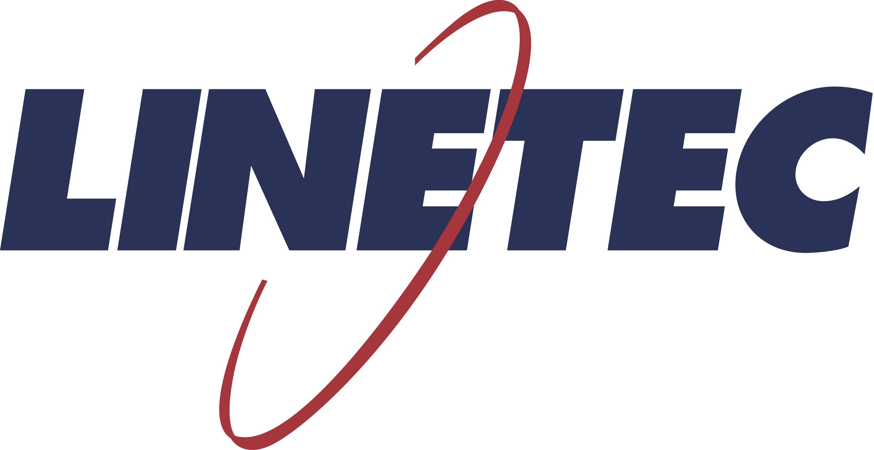
Media contact:
Heather West
612-724-8760
heather@heatherwestpr.com

Linetec’s Jon Close promoted to president, Rick Marshall to retire

Wausau, Wisconsin (Dec. 13, 2019) – Jon Close has been promoted to president of Linetec; succeeding Rick Marshall who will retire at the end of the company’s fiscal year.

During his nearly 24 years as Linetec’s president, Marshall helped guide Linetec to becoming the nation’s leading architectural finisher. Marshall and Close have worked together at Linetec for 16 years, supporting customers’ increased needs for a single source of high-quality, high-performance, finished, architectural aluminum products.

Drawing from more than 20 years of experience in the finishing industry, Close started with Linetec in 2003 as a commercial sales manager. He was promoted in 2006 to his most recent role as vice president of sales and marketing. Prior to joining Linetec, he worked at International Hardcoat as sales representative. He earned a degree in business administration and management from Upper Iowa University. He has applied his education and experience to numerous business leadership projects.

In his role as company president, Close will continue building upon the strategic business priorities and philosophy established by Marshall. “As a Single Source Solution, we go beyond finishing to partner with customers and offer services that enhance their products and projects,” said Close. “Our customer service and success come from the value-based culture that Rick established and that every Linetec associate brings to life in their daily work.”

“Jon and I have shared a similar vision and leadership style. He is a strong and balanced leader with an in-depth understanding of this industry and our company,” said Marshall. “I’m proud of what we’ve accomplished and excited for the continued success of Linetec and its customers.”

About Linetec
Located in Wisconsin, Linetec serves customers across the country, finishing such products as aluminum windows, wall systems, doors, hardware and other architectural metal components, as well as automotive, marine and manufactured consumer goods. The company is a subsidiary of Apogee Enterprises, Inc. (NASDAQ: APOG).

Linetec is a member of the Aluminum Anodizers Council (AAC), the American Architectural Manufacturers Association (AAMA), the American Institute of Architects (AIA), the Association of Licensed Architects (ALA), the National Glass Association/Glass Association of North America (NGA/GANA) and the U.S. Green Building Council (USGBC).
###

