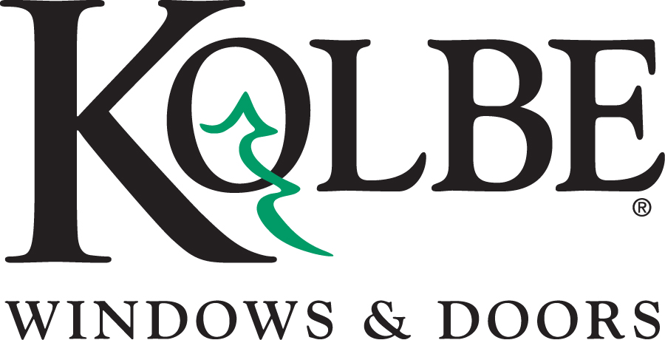

Kolbe will be exhibiting at the NAHB International Builders’ Show in Booth #W3600
Media contacts: Heather West, 612-724-8760, heather@heatherwestpr.com

Kolbe’s Forgent Series products integrate innovation and technology

Wausau, Wisconsin (Jan. 2022) – During the National Association of Home Builders International Builders’ Show (NAHB IBS), Kolbe Windows & Doors will highlight the strength and technology behind its Forgent® Series products in booth #W3600.

With a blend of innovative design, advanced technology and proprietary Glastra® material, Kolbe’s Forgent Series windows and doors are designed for strength, durability and energy efficiency. Continually reimagining the possibilities, Kolbe introduces AccuForge™ – an innovative, miter joint technology. This state-of-the-art nip-welding process creates a stronger, airtight and watertight seam with a smooth, high-end finish.

“Adapting the precision of AccuForge, Forgent Series enhances its alignment further with the aesthetic and performance demands of the market,” said vice president of Kolbe’s Manawa Division, Mark Harger.

Engineered with Glastra exteriors and a choice of Glastra or wood interiors, Forgent Series products offer consistent performance, popular finishes and impact-resistant capabilities.

Some unique configurations of Kolbe’s Forgent Series can be seen at IBS:

- A Forgent Series complementary sliding door with midnight interiors and exteriors is a center-opening, four-wide unit with 7-foot-8-inch-tall panels and coordinating matte black Allure™ handles. Above the sliding doors are Glastra/wood direct sets and a segment head window with pine interiors painted black.

- A Glastra/wood direct set, casement and awning display demonstrates a variety of products that combine to create floor-to-ceiling views. The windows have a bronze exterior and a coffee bean-stained wood interior, with 2-1/4-inch performance divided lites. Matte black nesting handles on the casements and awnings visually blend in, while the frames boldly outline the views.

- A Forgent Series Glastra/wood casement with 7/8-inch performance divided lites combines with two direct sets for views and ventilation. With a cloud exterior and a white painted pine interior, this unit is completed with the soft accent of a satin nickel nesting handle on the casement.

- An all Glastra two-wide new construction, double hung window unit with a midnight interior and exterior offers a 6-foot-11-inch by 5-foot-5-1/2-inch opening. Black 3/4-inch contoured grilles-in-the-airspace add detail to the top sash, while matte black hardware completes the unit.

“Kolbe listens to the needs of our market to provide solutions for builders, architects and homeowners everywhere,” said Jeff DeLonay, president of Kolbe Windows & Doors. “Persistent innovative thinking and state-of-the-art technology allow Forgent Series windows and doors to continue to evolve above vinyl and fiberglass products.”

To learn more about Kolbe’s Forgent Series, please visit https://www.kolbewindows.com/Forgent

What began in 1946 as a two-brother team has grown into an internationally respected manufacturing company. Kolbe Windows & Doors is one of the nation’s leading manufacturers of windows and doors for residential and commercial markets. After 75 years, Kolbe products are best known for superior quality, custom craftsmanship, attention to detail, as well as innovative and unique designs.

###

