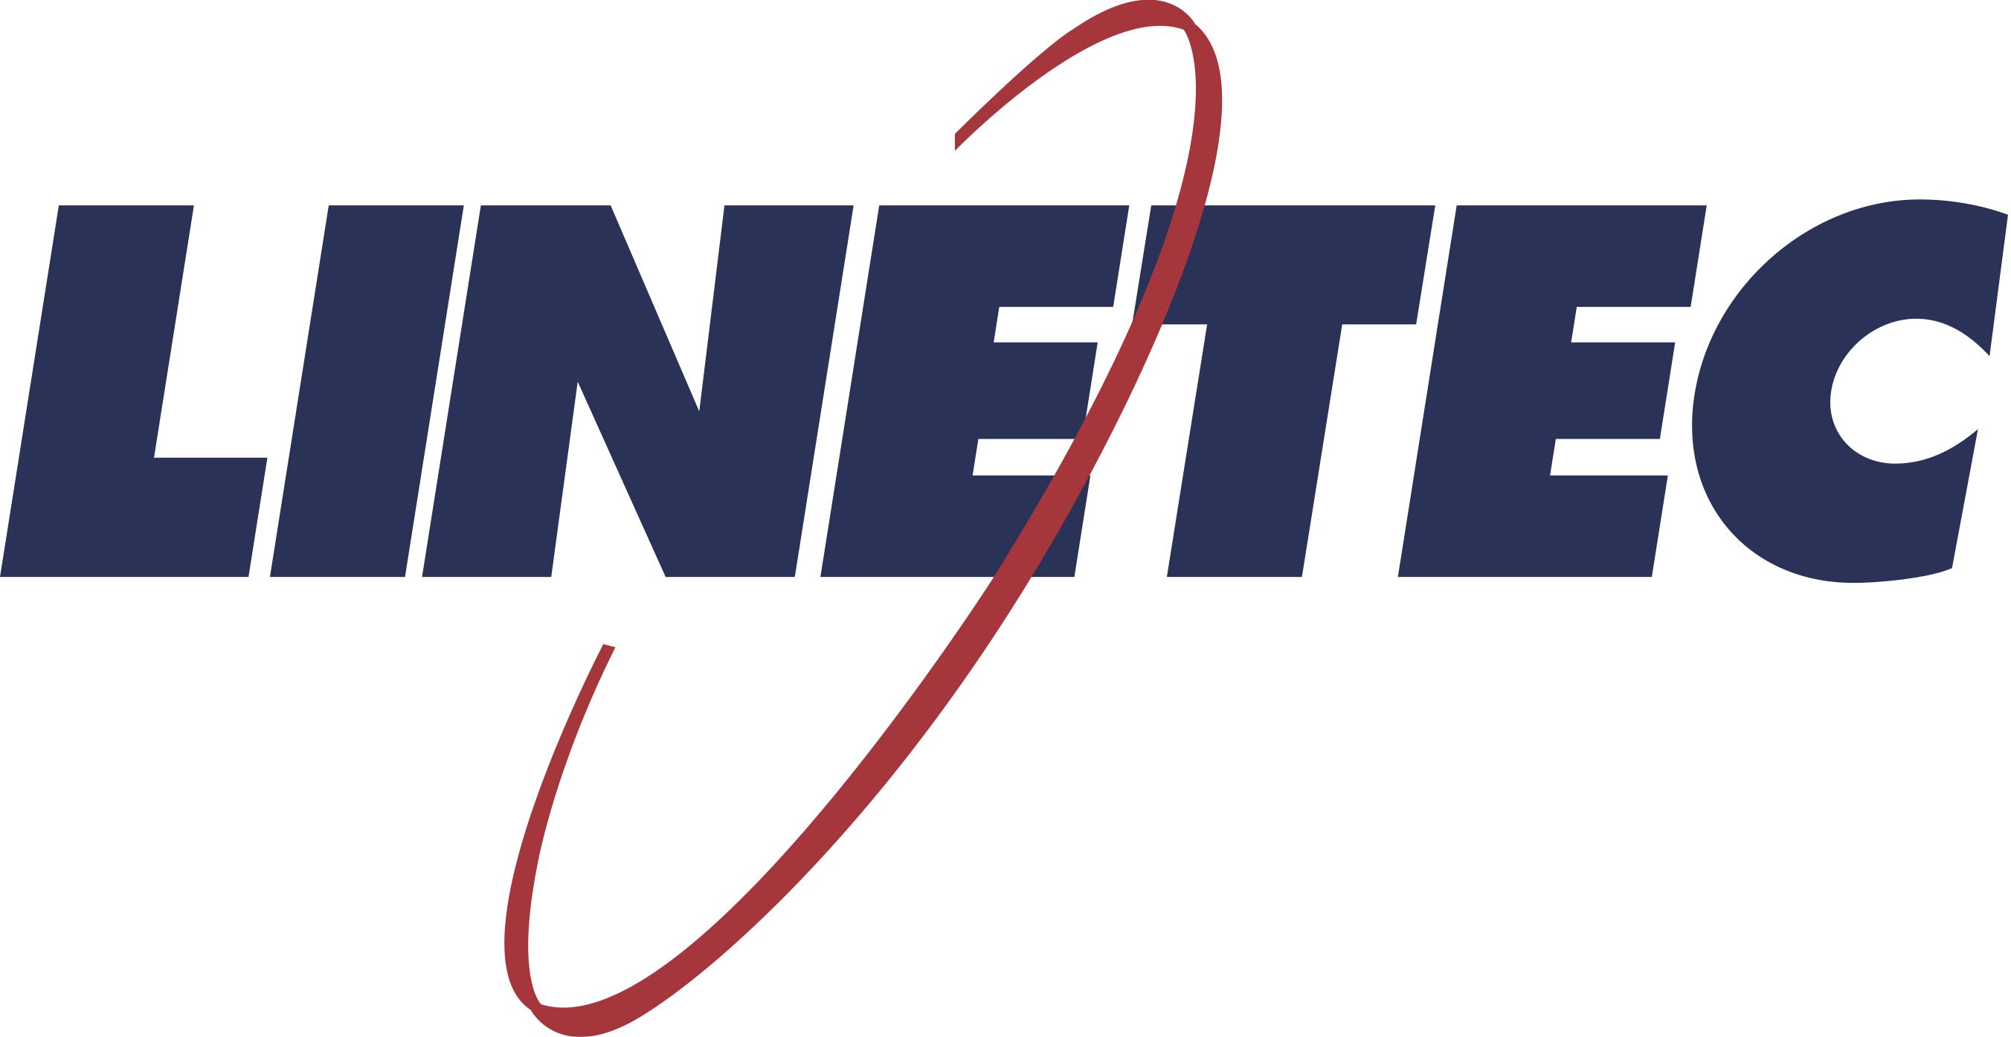
Media contact:
Heather West
612-724-8760
heather@heatherwestpr.com

Franklin Tower transforms former offices into luxury living,
re-clad in glass and metal with wood grain finishes from Linetec

Wausau, Wisconsin (Sept. 2019) – Franklin Tower Residences updates the Philadelphia skyline with 550 luxury apartments fashioned from a former concrete, office tower. The 1980’s structure has been converted into a premier, modern, residential property. Its exterior was re-clad in energy-efficient glass and thermally improved aluminum framing finished by Linetec.

As a single source solution, Linetec provided the anodize, paint and specialty wood grain finishes for the aluminum framing members of Franklin Tower’s numerous glazing systems:

- For the Franklin Tower Residences’ high-profile, street-level entrances and curtainwall, Linetec’s European Cherry wood grain finishes for aluminum present the look of wood without the maintenance of actual lumber. Unlike natural wood, the finished aluminum does not swell, rot, warp or attract insects. The finishes also are fire retardant; resist corrosion, water and humidity; and meet the American Architectural Manufacturers Association’s AAMA 2604 specification standard.

- The majority of Franklin Tower Residences’ window, curtainwall and entrances systems were finished by Linetec in a Bright Silver color using a four-coat metallic Duranar® XL 70% PVDF resin-based architectural coating. A two-coat mica Duranar Sunstorm also was applied in a Shanghi Silver color.

Metallic and mica painted finishes meet the AAMA 2605 specification standard for the highest level of performance. Protecting against UV damage, they bring a vibrant sparkle to the building’s previous austerity. The color can seem to change with the way the visible light is reflected off the surface, depending on the intensity and angle of the light.

- For Franklin Towers’ metal accents, Linetec’s Class I black anodize finish further highlights the project’s modern aesthetic. Linetec’s anodizing provides industry-leading durable performance, meeting AAMA 611 specification standard.

In addition to enhancing and protecting the curtainwall, window wall and door systems’ visible surfaces, Linetec also improved the framing systems’ thermal performance by separating the aluminum profile into two parts and adding polyamide insulating strips (thermal strut). This method of thermal improvement maintains the systems’ structural and long-term durability, while reducing heat transfer and condensation, and providing residents with a comfortable interior temperature year-round.

Re-envisioning and Revitalizing with Retrofit
Franklin Tower Residences’ 24-story building encompasses more than 607,000 square feet consisting of one- and two-bedroom luxury apartments offering generously sized floor plans, high ceilings, expansive window views through Viracon’s glass, ample natural light with floor-to-ceiling windows by Wausau Window and Wall Systems and entrance doors by Tubelite.

Building owner PMC Property Group relied on Gensler to design the renovated residential tower and transform the original architecture of Geddes Brecher Qualls & Cunningham (GBQC). General contractor Fastrack Construction managed the retrofit project for an on-time, on-budget delivery. Apogee Enterprises, Inc.’s Renovation team (Apogee Renovation) assisted with energy-efficient, cost-effective recommendations to upgrade the building envelope.

“When Gensler was approached by PMC Property Group to re-envision One Franklin Tower and to replace its existing façade, we saw our challenge as more than just replacing the skin on an aging building,” explained Gensler Principal Robert Fuller, AIA. “Our approach was to ask a question critical to today's cities: How can we continue to revitalize and reposition buildings that are no longer responding to the needs of their owners and tenants? Our challenge was to create a building that could enliven the public realm at street level, modernize and improve the functionality of its floor plates, and accommodate new homes for a growing downtown population.”

To do this, Gensler looked at developing an adaptive façade to replace the outdated precast, single-glazed strip-window façade. “While that exterior was built for a single use, the rhythm of the new façade allows for a variety of programmatic uses,” said Fuller. “The recessed channels at the vertical columns and horizontal spandrels express the structural module of the building, while the floor-to-ceiling glass creates a lighter façade that connects the interior spaces to views of the city beyond.”

At ground level, Gensler also increased both the transparency and the scale of the spaces by bringing the new storefront out to the sidewalk edge, eliminating the dark arcades that previously existed and better connecting the building to the surrounding community.

Fuller added, “Buildings built in the late ’70s through the mid-’80s are beginning to age out of their highest and best use as our cities have changed into highly condensed urban centers that blur the lines between live, work and play. One Franklin Tower offers a proposal to re-engage those buildings and bring them and the areas around them new life.”

Single Solution, Multiple Glazing Systems
Apogee Renovation – in conjunction with Wausau, Tubelite, Viracon, Linetec and its other businesses – assists building owners and property managers in evaluating the benefits of window renovation and upgrades. These include improving the appearance of the building, saving energy, downsizing HVAC loading, reducing maintenance, lowering vacancy rates, increasing rental rates and enhancing the value of the building.

For Franklin Tower Residences, Apogee Renovation worked with Wausau’s associates to provide PMC Property Group with design-assist and product selection services. Meeting the specified performance and desired aesthetic for Franklin Tower Residences, Wausau supplied Reilly Glazing with the window wall, operable vents and doors. Tubelite Inc. supplied the entrance systems, also finished and thermally improved by Linetec.

Residents and visitors to Franklin Tower are welcomed through two distinct, ground floor lobbies. The high-rise elevator lobby is on the south side of the building and has its own entrance off of Race Street, while the second lobby has an entrance on 16th Street and includes the low-rise and mid-rise elevator banks.

Reilly Glazing installed Tubelite’s standard, narrow stile entrances at ground level along with Wausau’s 9250i-UW INvision™ unitized curtainwall. From the second floor to the rooftop, Wausau supplied approximately 200,000 square feet of 7250i HRX INvision window wall with more 700 zero-sightline operable vents and 166 terrace doors. Wausau’s CrossTrak™ sliding doors and Tubelite Inc.’s Therml=Block® entrances also complement the rooftop deck and lounge, presenting panoramic views.

Along with improving the building’s expansive views and appearance, the window wall and entrance systems also contribute to a more energy-efficient, comfortable interior. Viracon’s VE-2M 1-inch insulating glass in a soft gray color with low-e coatings for improved thermal performance.

Combined with high-performance Viracon glass, Wausau’s HRX system can achieve thermal performance of 0.33 U-value, and Condensation Resistance Factor of CRF_{f} 76/CRF_{g} 72. The window wall also meets the American Architectural Manufacturers Association’s AAMA-1503 stringent test requirements for air, water and structural integrity.

Within the window wall, the operable vents allow for natural light and views, as well as for easy accessibility to natural ventilation. Along with fresh air, this offers a seasonal opportunity to reduce HVAC loads and associated energy consumption. The operable vents also are engineered and tested in accordance with AAMA 513, and in compliance with the Americans with Disabilities Act (ADA) criteria per ANSI A117.1.

Accelerated Installation, Dependable Results
“Wausau’s products performed effortlessly,” said Dan Reilly of Reilly Glazing, “Their materials shipped as scheduled, and were labeled and sequenced correctly. With some window units weighing up to 800 pounds, we found them simple to install with the proper equipment.”

“We were able to complete about a floor per week, to meet that fast-track schedule,” agreed Reilly. “We couldn’t have planned it any better. From engineering through installation, the entire project ran seamlessly. The client is extremely happy. It’s a beautiful building.”

**

Franklin Tower Residences, 200 North 16th Street, Philadelphia, PA 19102;
https://franklin-tower.com
- Owner: PMC Property Group; Philadelphia; https://www.pmcpropertygroup.com
- Original architect (1979): Geddes Brecher Qualls & Cunningham
- Architect: Gensler; Philadelphia; https://www.gensler.com/offices/philadelphia
- General contractor: Fastrack Construction; Fort Washington, Pennsylvania
- Glazing system – contractor: Reilly Glazing; Norristown, Pennsylvania
- Glazing system – window wall, vents, terrace doors and sliding doors manufacturer: Wausau Window and Wall Systems, an Apogee Enterprises company; Wausau, Wisconsin; http://www.wausauwindow.com
- Glazing system – entrance doors manufacturer: Tubelite Inc., an Apogee Enterprises company; Walker, Michigan; https://www.tubeliteinc.com
- Glazing systems – glass fabricator: Viracon, Inc., an Apogee Enterprises company; Owatonna, Minnesota; http://www.viracon.com
- Glazing systems – aluminum finisher: Linetec, an Apogee Enterprises company; Wausau, Wisconsin; https://linetec.com
- Photos by: Greg Benson Photo
- Video – virtual tours: https://franklin-tower.com/virtual-tours

About Linetec
Located in Wisconsin, Linetec serves customers across the country, finishing such products as aluminum windows, wall systems, doors, hardware and other architectural metal components, as well as automotive, marine and manufactured consumer goods. The company is a subsidiary of Apogee Enterprises, Inc. (NASDAQ: APOG).

Linetec is a member of the Aluminum Anodizers Council (AAC), the American Architectural Manufacturers Association (AAMA), the American Institute of Architects (AIA), the Association of Licensed Architects (ALA), the National Glass Association/Glass Association of North America (NGA/GANA) and the U.S. Green Building Council (USGBC).

To learn more about Linetec’s finishing and value-added services, please call 888-717-1472, email sales@linetec.com or visit https://linetec.com.

###

