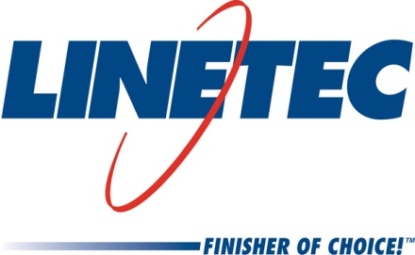
Media contacts:
Heather West, 612-724-8760
heather@heatherwestpr.com
and
Tammy Schroeder, 715-846-3714
tammy.schroeder@linetec.com

Linetec’s Tom Danen honored with Patriot Award
Presented by Department of Defense for extraordinary support of employees who serve in the Wisconsin National Guard and Reserve
Wausau, Wisconsin (Sept. 2017) – The Wisconsin Committee for Employer Support of the Guard and Reserve (ESGR), an agency of the U.S. Department of Defense, honored Linetec’s production supervisor for paint applications Tom Danen with a Patriot Award.

Spc. Andrew Jimenez nominated Danen for “extraordinary support” of employees who participate in military service. Jimenez serves in the U.S. Army Reserve, assigned to the 687th Combat Sustainment Support Battalion in Brokaw, Wisconsin. Before joining the Guard full-time, he worked with Danen at Linetec in Wausau, Wisconsin.

On Sept. 6, Dave Monk, ESGR representative, presented the Patriot Award to Danen at Linetec’s facility. After graciously accepting the award, Danen commented, “It was a pleasure working with Andrew. His hard work and dedication to his job at Linetec were greatly appreciated. I greatly admire and thank Andrew for his service in the U.S. Army Reserve.”

Danen noted that he grew up in a military family, and both of his parents were in the Reserve. He remembered, “The companies they worked for were flexible with their work schedules, so it just came second nature to me that Linetec would be this way.”

“Tom Danen has provided outstanding support and cooperation, and has exhibited a patriotic spirit, which is reflected in the significance of being a recipient of the Patriot Award,” said Williams. “The Patriot Award is only presented to employers who not only hire Guard and Reserve members, but demonstrate superior support to the military employee and his or her family. The National Guard and Reserve forces are the cornerstone of our national defense.”

The U.S. National Guard and Reserve currently includes 1.3 million members. The ESGR accepts Patriot Award nominations from all members of the National Guard and Reserve. Learn more at www.esgr.mil.

For more information about Linetec and its employment opportunities, please call 888-717-1472 or visit the "Employment" section of the website.

Located in Wisconsin, Linetec serves customers across the country, finishing such products as aluminum windows, wall systems, doors, hardware and other architectural metal components, as well as automotive, marine and manufactured consumer goods. The company is a subsidiary of Apogee Enterprises, Inc. (NASDAQ: APOG).

Linetec is a member of the Aluminum Anodizers Council (AAC), the American Architectural Manufacturers Association (AAMA), the American Institute of Architects (AIA), the Association of Licensed Architects (ALA), the Glass Association of North America (GANA), the U.S. Green Building Council (USGBC) and the Window and Door Manufacturers Association (WDMA).
###

