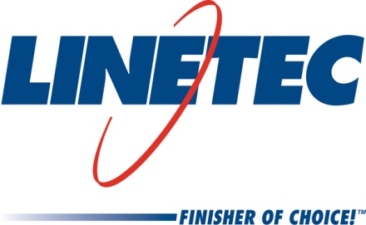
Media contacts:
Heather West, 612-724-8760
heather@heatherwestpr.coms

Linetec names Phil Bauer as Southern territory sales manager
Wausau, Wisconsin (Nov. 2017) – Linetec has hired Phil Bauer as its sales manager serving customers in Missouri, Kansas, Oklahoma, Arkansas, Louisiana, Arizona, New Mexico and Texas. He reports directly to Jon Close, Linetec’s vice president of sales and marketing.

Located in Wisconsin, Linetec provides paint and anodize finishing for such products as aluminum windows, wall systems, doors, hardware and other architectural aluminum building components, as well as stretch forming, thermal improvement and restoration services. The company continues to expand its operations and staff to serve customers across the country.

Bauer most recently worked in Ohio as a Midwest sales manager for SIFCO ASC, one of the world’s largest suppliers of contract selective electroplating and anodizing services, products and chemical solutions. Previously, he worked in the automotive and home center industries with consumer and commercial customers.

Before beginning his sales career, Bauer is a graduate of the University of Akron. He also has completed several professional training certifications.

For more information about Linetec and its employment opportunities, please call 888-717-1472 or visit the "Employment" section of the website.

Located in Wisconsin, Linetec serves customers across the country, finishing such products as aluminum windows, wall systems, doors, hardware and other architectural metal components, as well as automotive, marine and manufactured consumer goods. The company is a subsidiary of Apogee Enterprises, Inc. (NASDAQ: APOG).

Linetec is a member of the Aluminum Anodizers Council (AAC), the American Architectural Manufacturers Association (AAMA), the American Institute of Architects (AIA), the Association of Licensed Architects (ALA), the Glass Association of North America (GANA), the U.S. Green Building Council (USGBC) and the Window and Door Manufacturers Association (WDMA).
###

