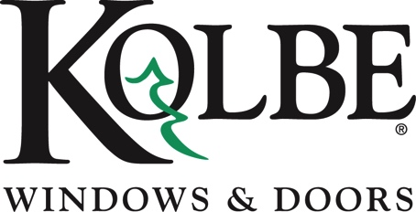

Kolbe will be exhibiting at the NAHB International Builders’ Show in Booth #W3600

Media contact: Heather West, 612-724-8760, heather@heatherwestpr.com

Kolbe’s entrance doors incorporate
personalization of style and scale

Wausau, Wisconsin (Jan. 2022) – Kolbe Windows & Doors is showcasing entrance door systems at the National Association of Home Builders International Builders’ Show (NAHB IBS) in booth #W3600, with emphasis on style and scale.

“Because today’s homeowners are more in tune with their living space than ever before, they want it to reflect their personality. Selecting an entry door that is mostly glass, a bold color or intricate wood detail helps express their individual style and sets the tone for the rest of the home,” said Liz Huber, marketing manager at Kolbe Windows & Doors.

Whether historical, traditional or modern in design, Kolbe offers one-of-a-kind doors for both residential and commercial projects with various configurations, functionality and options, including wood species, divided lites, glass, hardware, finishes and more. Kolbe’s offering of custom inswing and outswing doors also includes pivot doors within the Ultra Series and VistaLuxe® Collection.

Some examples of Kolbe’s entrance door solutions can be seen on display in booth #W3600.

- A 3-1/2-by-10-foot reclaimed barnwood door is a sustainable solution for a 7-by-12-foot entryway that blends rustic character with modern design. Constructed of reclaimed wood, this outswing door offers a natural contrast with the onyx extruded aluminum exterior trim, and is surrounded by direct set sidelites, while an upper transom accentuates the height of the unit. Equipped with an electronic multi-point lock, this impressive barnwood door features a stylish Hoppe® pull handle in a brushed stainless finish, which reinforces verticality against the horizontal panels of clear-coated wood.

- A 5-by-10-foot VistaLuxe WD LINE complementary pivot door offers a light-filled entryway with specialized hardware that allows for easy operation. The door features an extruded aluminum bordeaux anodized exterior applied as a custom finish, with a warm mahogany clear-coated wood interior. The square details, narrow 5-inch stiles and rails, and satin stainless steel Rockwood® GeoMetek locking pull handle add stylish sophistication to this one-of-a-kind door.

For complete information and product details on Kolbe’s extraordinary entrance doors, please visit https://www.kolbewindows.com.

What began in 1946 as a two-brother team has grown into an internationally respected manufacturing company. Kolbe Windows & Doors is one of the nation’s leading manufacturers of windows and doors for residential and commercial markets. After 75 years, Kolbe products are best known for superior quality, custom craftsmanship, attention to detail, as well as innovative and unique designs.

###

