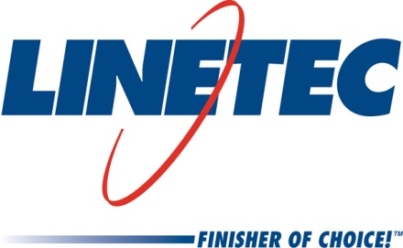
Media contacts:
Heather West, 612-724-8760, heather@heatherwestpr.com
Tammy Schroeder, 715-846-3714, tammy.schroeder@linetec.com

Linetec continues to meet customers’ growth

by expanding capacity, adding jobs

Wausau, Wisconsin (Oct. 2016) – Linetec continues to support its customers’ growth and the architectural metal products market’s increased demand for high-quality finishing. The company is expanding shift coverage and enhancing production flow to gain significant capacity at its paint facility in Wausau, Wisconsin. Before Jan. 1, 2017, the company plans to add at least 40 new jobs to its paint facility, including two supervisors and all levels of production associates.

“Linetec has added nearly 100 jobs in the last year and we are excited to have more positions to fill,” says Jane Kessel, Linetec’s vice president of human resources. “The jobs created have been good paying jobs. Our starting rates are $15 per hour plus premiums and bonuses.”

The paint facility’s capacity expansion continues to leverage advancements in technology and capitalize on Linetec’s best practices In addition to adding more positions for increased shift coverage, Linetec’s continual improvement efforts also have yielded more efficient and increased productivity.

Following the 180,000-square-foot physical expansions completed last year, Linetec’s campus now spans more than 750,000 square feet. From its Wisconsin location, Linetec’s customers across North America benefit from short and reliable lead times; a choice of anodize, liquid paint and powder coating finishes; and supplemental services, such as thermal improvement, stretch forming and inventory management of their architectural metal products.

For more information about Linetec’s facility, finishing services and employment opportunities, please visit http://www.linetec.com.

Located in Wisconsin, Linetec serves customers across the country, finishing such products as aluminum windows, wall systems, doors, hardware and other architectural metal components, as well as automotive, marine and manufactured consumer goods. The company is a subsidiary of Apogee Enterprises, Inc. (NASDAQ: APOG). Linetec is a member of the American Institute of Architects (AIA), the Association of Licensed Architects (ALA), the International Interior Design Association (IIDA), the American Architectural Manufacturers Association (AAMA) and the U.S. Green Building Council (USGBC).
###

