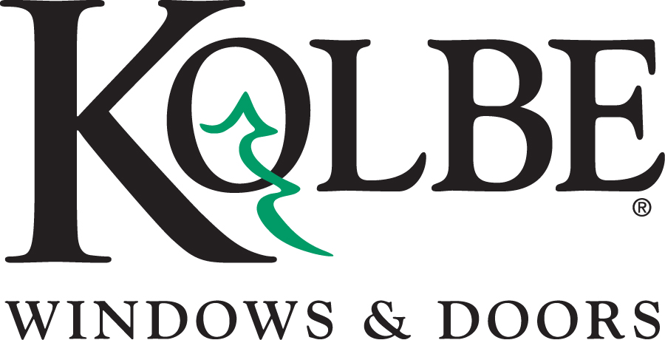

Kolbe will be exhibiting at the NAHB International Builders’ Show in Booth #W3870
Media contacts: Heather West, 612-724-8760, heather@heatherwestpr.com
Bethany Hoffmann, 715-847-0719, bethany.hoffmann@kolbewindows.com

Kolbe’s new Forgent™ Series offers simplicity,
easy installation and short lead times

Wausau, Wisconsin (Jan. 2017) – During the NAHB International Builders’ Show in booth #W3870, Kolbe Windows & Doors will introduce a brand new product line: the Forgent™ Series.

“Kolbe’s dedication to innovation, quality and product design has led to our development of the Forgent™ Series,” states Jeff De Lonay, president of Kolbe Windows & Doors. “Designed for strength, performance and ease-of-installation, Forgent windows feature proprietary material and thoughtful design, making them simple, convenient and easy to install. Short lead times for projects requiring windows and doors quickly make the Forgent Series a perfect choice for new construction or replacement.”

Forgent Series offers multiple window types – casements, awnings, double hungs and sliding windows – constructed of Glastra™, a proprietary material formulated for strength and resilience. “This unique material, a hybrid fiberglass and UV-stable polymer, is designed for quality, performance and value,” explains De Lonay.

These windows are engineered with Glastra on the exterior, with either wood or Glastra on the interior. Multi-chambered Glastra extrusions in an advanced ladder design add strength and resiliency and promote energy efficiency. An integral nailing fin and welded sash and frame provide rigidity, keeping units square and preventing air and water from entering the joint.

In addition to Forgent windows, the Forgent Series includes complementary specialty windows, sliding patio doors and swinging patio doors. These complementary products offer the same aesthetic options and same short lead times, ensuring builders can get all of the windows and doors for their project quickly.

A number of Forgent Series products are displayed in booth #W3870:

- A crank-out casement with a transom mulled above has a Glastra exterior with Midnight acrylic film, a Pine interior with latex primer, energy-efficient, triple pane glass, and White hardware.

- A second crank-out casement is shown with a complementary segment head direct set transom. With an integral Cloud color, the Pine interior is shown with a field-applied clear coat. Seven-eighths-inch performance divided lites divide energy-efficient insulating glass, while Satin Nickel hardware adds the finishing touch.

- A double hung with a Glastra exterior in Sahara and Bronze acrylic film on the sash is complemented by a Pine interior with a field-applied clear coat. Energy-efficient insulating glass, grilles-in-the-airspace and Clay hardware complete the window.

- A studio double hung with a Glastra exterior and Bronze acrylic film features a Pine interior with latex primer, ready for finishing. A transom is mulled above, with energy-efficient glass and performance divided lites.

- A 5-by-6-foot single sliding window with a Glastra exterior, an integral Cloud interior and White hardware opens easily to provide a large opening.

- A crank-out awning with a picture window mulled above has a Glastra exterior with Midnight acrylic film. Accented by 2-inch brickmould, an integral Cloud interior and White hardware, this unit features energy-efficient insulating glass.

- A sliding patio door, to complement All Glastra windows, is shown with an integral Sahara interior and exterior, a Champagne sill, Clay hardware with multi-point lock and 7/8-inch performance divided lites.

- An inswing patio door complements Glastra/Wood windows. With a Bronze exterior and a Pine interior shown with a field-applied clear coat, the Matte Black Toronto handle set adds an elegant touch.
“Through ongoing research of new materials and development of advanced design, Kolbe continues to meet the needs of home builders, architects and homeowners everywhere,” says De Lonay. “We constantly innovate to bring the best products to the market, and our new Forgent Series really delivers when it comes to efficiency, convenience and performance.”

What began in 1946 as a two-brother team has grown into an internationally respected manufacturing company. Kolbe Windows & Doors is one of the nation’s leading manufacturers of windows and doors for residential and commercial markets. After 70 years, Kolbe products are best known for superior quality, custom craftsmanship, attention to detail, as well as innovative and unique designs.
###

