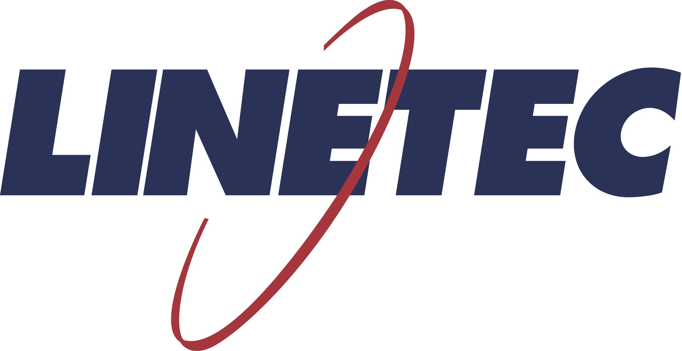
Media contact:
Heather West
612-724-8760
heather@heatherwestpr.com

Pergolas showcase wood look without the maintenance
using Linetec’s wood grain finishes for aluminum

Wausau, Wisconsin (Feb. 2021) – As more people seek to safely gather, pergolas expand outdoor functional gathering spaces by providing structure, definition and distinction to greenspaces, yards, sidewalks and patios. Linetec’s wood grain finishes allow pergolas to present the natural look of real wood, while benefitting from lower maintenance and greater longevity.

“Typically constructed of real wood, the enjoyment of a pergola can be hampered by the need for ongoing maintenance, seasonal storage and short lifespans. Overcoming these obstacles, pergolas now can be manufactured with aluminum and finished in wood grain coatings for a similar aesthetic to the natural beauty of wood, but with less care and longer lifespans,” said Linetec’s marketing manager, Tammy Schroeder, LEED® Green Associate.

Linetec’s specialty finishes for architectural aluminum products include more than 50 wood grain options of species and color along with textured grain patterns. These finishes can replicate expensive hardwoods like oak and walnut that may otherwise be cost-prohibitive for pergolas.

Durable and practical, Linetec’s wood grain finishes on aluminum deliver a consistent appearance and reliable performance. Unlike actual wood, aluminum pergolas will not rot, swell or warp. Scratch- and corrosion-resistant, these finishes provide durable protection from UV rays and are impervious to humidity and insects.

Within its quality-controlled finishing facility, Linetec applies these coatings utilizing a powder coat sublimation process to meet or exceed the AAMA 2604 standard. At the end of their useful life as a pergola, the finished aluminum can be recycled.

To learn more about Linetec’s specialty wood grain coatings for aluminum please visit https://linetec.com/specialty-finishes/wood-grain.

About Linetec
Located in Wisconsin, Linetec serves as a single source solution for architectural finishing. The company works with customers across the country, finishing such products as aluminum windows, wall systems, doors, hardware and other architectural metal components, as well as automotive, marine and manufactured consumer goods.

Linetec is a member of the Aluminum Anodizers Council (AAC), the American Institute of Architects (AIA), the Fenestration & Glazing Industry Alliance (FGIA), the National Glass Association (NGA) and the U.S. Green Building Council (USGBC). The company is a subsidiary of Apogee Enterprises, Inc. (NASDAQ:APOG).

Please visit https://linetec.com for more information about Linetec’s architectural paint, anodize and specialty finishes.
###

