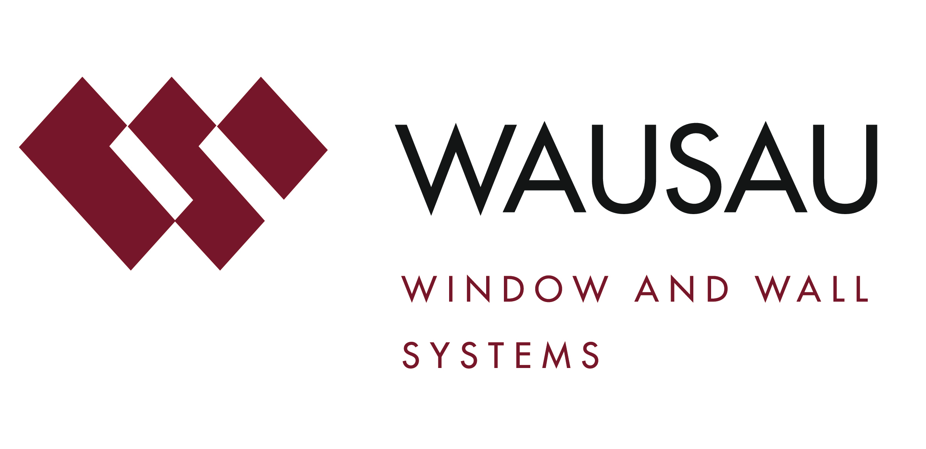
Media contact: Heather West, 612-724-8760, heather@heatherwestpr.com

Wausau Window and Wall Systems honored with Wisconsin Corporate Safety Award and celebrates 14th year as an award finalist

Wausau, Wisconsin (June 2022) – Wisconsin Safety Council honored Wausau Window and Wall Systems as a 28th Annual Wisconsin Corporate Safety Awards winner. The company is one of only 10 in the state to earn this grand award for exemplary safety records and excellence in safety and health management.

Wausau is one of four of the grand award winners in the manufacturing category and the only in the large “size 3” classification with three Wisconsin locations and approximately 400 employees. This is the fourteenth consecutive year Wausau has been recognized as a finalist and the second time it has earned the prestigious award. Wisconsin Corporate Safety Award winners are determined by an independent panel of judges who are safety, health and insurance professionals.

For more than 65 years, Wausau has engineered and manufactured window and curtainwall systems for commercial and institutional buildings. As an industry leader, the company strives to provide customers with lasting value, quality, service and reliability, while remaining focused on employees’ safety, health and wellness.

“A ‘Safe and Enjoyable Work Environment’ is our first core value,” said Wausau’s safety manager, Doug Janz. “We believe that a remarkable safety program does not occur overnight; a company must be consistent and continually strive to improve their program to be beyond compliance.”

He added, “We have a great team of associates who bring these values to life and put safety as a priority each and every day. They are the ones who truly earned this award and make Wausau a winning place to work.”

As a Wisconsin Corporate Safety Award nominee, Wausau submitted data about its 2021 safety records and provided information about its safety and health leadership, training programs, team participation, culture, goals and successes.

The focus on safety is led by the operations team with full support and participation from the entire organization. All teams work together to implement ongoing solutions. Numerous initiatives and methods are used to drive improvement, including daily safety meetings, weekly safety “gemba” walks, three-tier approach to safety observations, scheduled “6S” checks, monthly continuous improvement events with embedded safety considerations, safety teams, an annual corporate safety audit and more. Associates are recognized for company and team milestones, and individually for their participation.

Through its commitment, Wausau’s cumulative OSHA-recordable injury rate for the last 10 years is 1.52. This is notably lower than the industry annual average of 5.40 recordable injuries for metal window and door manufacturing workers, as reported by the U.S. Bureau of Labor Statistics.

Wisconsin Safety Council is the state’s leading provider of safety training and products, serving members of all sizes and every sector of the economy. It is the official state chapter of the National Safety Council and a program of Wisconsin Manufacturers & Commerce– the state’s chamber of commerce.
(more)

The Wisconsin Corporate Safety Awards winners were recognized on the Wisconsin Safety Council’s website and at the 80th Annual Safety Conference held in April 2022.

About Wausau Window and Wall Systems
Nationally recognized for its innovative expertise, Wausau Window and Wall Systems is an industry leader in engineering window and curtainwall systems for commercial and institutional construction applications. For more than 65 years, Wausau has worked closely with architects, building owners and contractors to realize their vision for aesthetic beauty, sustainability and lasting value, while striving to maintain the highest level of customer service, communication and overall satisfaction. Wausau is a part of Apogee Enterprises, Inc., a publicly held, U.S. corporation.

Wausau and its staff are members of the American Institute of Architects (AIA), the APPA – Leadership in Educational Facilities, the Construction Specifications Institute (CSI), the Fenestration and Glazing Industry Alliance (FGIA), the National Fenestration Ratings Council (NFRC), the National Glass Association (NGA), and the U.S. Green Building Council (USGBC).
###

