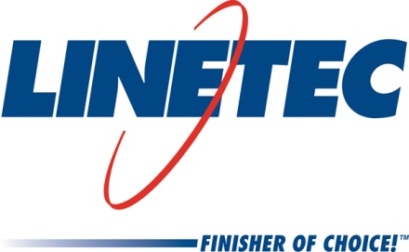
Media contact:
Heather West
612-724-8760
heather@heatherwestpr.com

Pennsylvania’s Crozer-Chester Medical Center’s
40-foot-diameter skylight finished by Linetec

Wausau, Wisconsin (April 2016) – Crozer-Chester Medical Center in Chester, Pennsylvania, designed by Charles Cross Architecture, features a 40-foot-diameter dome skylight, manufactured and installed by Super Sky Products Enterprises, LLC. Linetec finished the 1,411-square-foot skylight’s aluminum framing in a Silver mica high-performance architectural coating.

Linetec’s senior marketing specialist, Tammy Schroeder, LEED® Green Associate, explained, “The two-coat 70 percent polyvinylidene fluoride (PVDF) resin-based coating meets the industry’s stringent requirements set by the American Architectural Manufacturers Association – AAMA 2605. Coatings meeting this standard exhibit outstanding resistance to humidity, color change, chalk, gloss loss and chemicals for long-lasting performance that requires minimal maintenance throughout the buildings’ lifespan.”

As an environmentally responsible finisher, Linetec captures the liquid paints’ volatile organic compounds (VOCs) content to eliminate the exhaust of potential pollutants. The primary environmental concern with liquid paints is the solvents, which may have VOC content and must be destroyed safely. Linetec uses a 100 percent air capture system and destroys the VOCs with a regenerative thermal oxidizer, so there is no adverse environmental impact. Linetec then re-uses its heat energy byproduct to improve process energy efficiency. This process of re-use is completed before the material exits the paint line.

Further supporting Crozer-Chester Medical Center’s environmental benefits, the skylight systems offer natural light and views through Oldcastle’s insulated, low-e glass. To ensure proper performance, Super Sky’s installation team worked closely with general contractor John S. McManus, Inc.

Opened in 2010, Crozer-Chester Medical Center is a 300-bed not-for-profit tertiary-care teaching hospital located on a 68-acre campus. Today, the medical center admits more than 19,000 patients, treats approximately 53,000 emergency department patients and delivers about 1,700 babies a year.

**

Crozer-Chester Medical Center; One Medical Center Blvd., Chester, PA 19013; www.crozerkeystone.org/Locations/crozer-chester-medical-center
- Owner: Crozer-Keystone Health System; Springfield, Pennsylvania; www.crozerkeystone.org
- Architect: Charles Cross Architecture, P.C.; Wayne, Pennsylvania; www.chcarch.com
- General contractor: John S. McManus, Inc.; Chester Heights, Pennsylvania; www.jsmcmanus.com
- Skylight – manufacturer and installer: Super Sky Products Enterprises, LLC; Mequon, Wisconsin; www.supersky.com
- Skylight – glass manufacturer: Oldcastle BuildingEnvelope®; Perrysburg, Ohio; www.obe.com
- Skylight – finisher: Linetec; Wausau, Wisconsin; www.linetec.com
- Photo by: William Lemke, courtesy of Super Sky

Located in Wisconsin, Linetec serves customers across the country, finishing such products as aluminum windows, wall systems, doors, hardware and other architectural metal components, as well as automotive, marine and manufactured consumer goods. The company is a subsidiary of Apogee Enterprises, Inc. (NASDAQ: APOG). Linetec is a member of the American Institute of Architects (AIA), the Association of Licensed Architects (ALA), the American Architectural Manufacturers Association (AAMA) and the U.S. Green Building Council (USGBC).

For more information about Linetec’s finishing and other services please call 888-717-1472, email sales@linetec.com or visit www.linetec.com.

###

