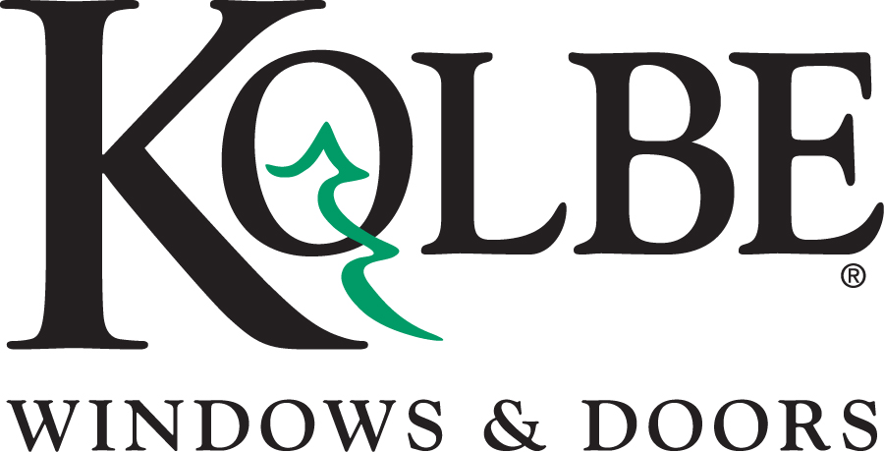

Kolbe will be exhibiting at the NAHB International Builders’ Show in Booth #W3870
Media contacts: Heather West, 612-724-8760, heather@heatherwestpr.com
Cindy Bremer, 715-847-0570, cindy.bremer@kolbewindows.com

Kolbe’s Forgent Series offers durability, efficiency and easy installation

Wausau, Wisconsin (Oct. 2017) – During the National Association of Home Builders International Builders’ Show (NAHB IBS) in booth #W3870, Kolbe Windows & Doors will highlight its Forgent® Series window and door products.

“Kolbe’s dedication to innovation, quality and product design has led to our development of the Forgent Series,” states Jeff De Lonay, president of Kolbe Windows & Doors. “Our proprietary Glastra® material, combined with unprecedented design, elevates these windows above other vinyl or fiberglass products. Short lead times for projects requiring windows and doors quickly make the Forgent Series a perfect choice for new construction or replacement.”

Forgent Series offers multiple window types – casements, awnings, double hungs and sliding windows – engineered with Glastra on the exterior, with either wood or Glastra on the interior. Multi-chambered Glastra extrusions in an advanced ladder design add strength and resiliency and promote energy efficiency. An integral nailing fin, and welded sash and frame provide rigidity, keeping units square and preventing air and water from entering the joint.

Demonstrating the strength of the Glastra material used in Forgent Series window and doors, visitors to Kolbe’s NAHB IBS booth will see videos of laboratory tests along with the products themselves. Three different installation methods also will be on display in the booth: integral nailing fin, installation clips and screw through frame. Builders can choose which installation option will be fastest and easiest for each project.

In addition to Forgent windows, the Forgent Series includes complementary specialty windows, sliding patio doors and swinging patio doors. These complementary products offer the same aesthetic options and same short lead times, ensuring builders receive all of the windows and doors for their project quickly.

Among the Forgent Series products on display in booth #W3870 are:
- A crank-out casement, with a half-circle direct set mulled above it, has an integral Sahara Glastra interior and exterior with 2-inch brickmould and Clay-colored hardware.
- A double hung, with sash-set transom, has a Glastra exterior with Midnight acrylic film and is complemented by a pine wood interior with a field-applied clear coat. Energy-efficient insulating glass and Clay hardware complete the window.

Three additional impact-resistant units are shown in Kolbe’s NAHB IBS booth. The sash and frame require no additional reinforcements to pass the rigorous impact testing – a testament to the Glastra material and the design of the window. These all-Glastra units are certified for Wind Zone 4:
- A crank-out casement has a Glastra exterior with Bronze acrylic film and a primed latex interior, ready for field finishing. Its 7/8-inch impact laminated glass provides security, and Satin Nickel hardware provides easy operation.
- A second double hung is shown with an integral Cloud Glastra interior and exterior. Its 7/8-inch performance divided lites divide 7/8-inch impact laminated glass.
- A sliding patio door, to complement All Glastra windows, is shown with an integral Cloud interior and exterior, Satin Nickel hardware with multi-point lock and impact laminated glass.
“Through ongoing research of new materials and development of advanced design, Kolbe continues to meet the needs of home builders, architects and homeowners everywhere,” says De Lonay. “We constantly innovate to bring the best products to the market, and our new Forgent Series really delivers when it comes to durability, efficiency and performance.”

What began in 1946 as a two-brother team has grown into an internationally respected manufacturing company. Kolbe Windows & Doors is one of the nation’s leading manufacturers of windows and doors for residential and commercial markets. After more than 70 years, Kolbe products are best known for superior quality, custom craftsmanship, attention to detail, as well as innovative and unique designs. To learn more, please visit https://www.kolbewindows.com.
###

