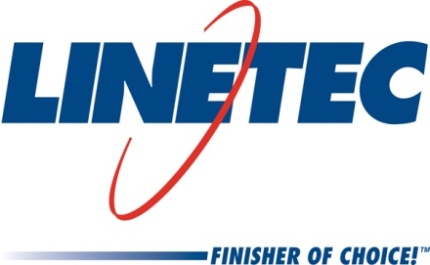
AIA Expo booth #3353
Media contact:
Heather West, 612-724-8760
heather@heatherwestpr.com

Linetec shares expertise on protecting coastal projects
with durable finishes

Wausau, Wisconsin (March 2017) – Helping protect coastal and seaside projects’ exterior-facing architectural aluminum products from corrosion, Linetec shares its expertise in the latest issue of “Architectural Finishing Facts,” a free eNewsletter. As part of its ongoing series of educational articles, “Choosing the right finish for coastal projects” is available on Linetec’s website [http://www.linetec.com/Linetec_News.html] and is emailed to more than 50,000 subscribers.

The article warns, “Without proper precautions and finishes, corrosion to these aluminum components can damage the building envelope’s structural integrity, leading to systemic failure.” It concludes, “With preventive measures in place, finished architectural aluminum retains its intended look and long life, while providing the desired performance in the harshest environments, including the highly corrosive seacoast. These qualities reduce the need to replace materials and components, conserve resources, optimize labor and save money.”

To mitigate corrosion’s destructive results, Linetec describes proper selection, specification, application and maintenance of finishes in coastal conditions. Both high-performance 70 percent PVDF coatings and Class I anodize finishes are highlighted as the most durable finishes for exterior-facing architectural aluminum products.

Linetec recommends these finishes meet the stringent standards of AAMA 2605-13 for paint coatings and AAMA 611-14 for anodize. In addition to resisting corrosion, these high-performance finishes are tested for proven resistance to water, salt spray, humidity, impact, chemicals, detergents, scratches and fading due to ultraviolet light. Finished aluminum also is fire retardant and does not swell, rot, warp or attract insects.

Supporting environmentally sound practices, anodize finishes contain no volatile organic compounds (no VOCs), and painted coatings should be applied in a controlled facility that safely captures and destroys the VOCs present in liquid solvent-based paints before the finished products’ arrival on the building site. Whether anodized or painted, the aluminum used to produce these products may utilize recycled content, and may be recycled after their useful lifespan.

Linetec will display samples of its durable finishes at the American Institute of Architects (AIA) Expo in booth #3353. For more information about Linetec’s finishing services for coastal projects and architectural aluminum products, or to subscribe to “Architectural Finishing Facts,” please call 888-717-1472, email sales@linetec.com or visit http://www.linetec.com.

Located in Wisconsin, Linetec serves customers across the country, finishing such products as aluminum windows, wall systems, doors, hardware and other architectural metal components, as well as automotive, marine and manufactured consumer goods. The company is a subsidiary of Apogee Enterprises, Inc. (NASDAQ: APOG). Linetec is a member of the American Institute of Architects (AIA), the Association of Licensed Architects (ALA), the International Interior Design Association (IIDA), the American Architectural Manufacturers Association (AAMA) and the U.S. Green Building Council (USGBC).
###

