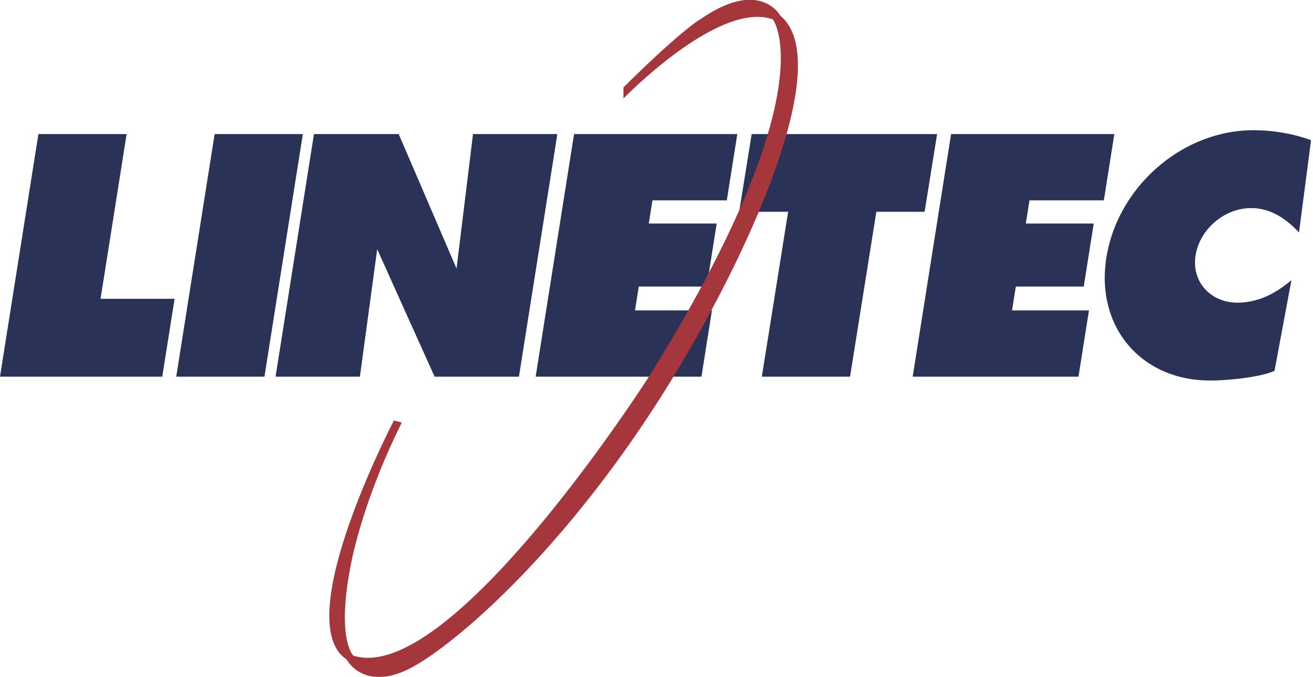
Media contact:
Heather West
612-724-8760
heather@heatherwestpr.com

Linetec announces Jake Kriewald as Mid-Central sales manager
serving customers in Michigan, Illinois, Indiana and Kentucky

Wausau, Wisconsin (March 2020) – Linetec has promoted Jake Kriewald from inside sales lead to outside sales manager for the Mid-Central states of Michigan, Illinois, Indiana and Kentucky. He reports directly to Linetec’s vice president of sales and marketing, Jeff A. Fochs, Jr., who previously managed the territory.

Linetec, the nation’s largest independent architectural metals finishing company, provides customers with a single source solution for high-performance architectural coatings, anodize and specialty finishes; thermal improvement services, stretch forming, and repair and restoration services.

In addition to Kriewald, Linetec’s other outside sales managers include Wendy Taylor for the Northwest, Tony Pupp for the North Central, Phil Bauer for the South and Scott Spaid for the East Coast. They work closely with marketing manager Tammy Schroeder, as well as Linetec’s quoting and estimating specialists, and its inside sales associates.

For the past five years, Kriewald worked as part of the inside sales team managing some of Linetec’s largest accounts. He previously worked in other sales and customer service roles, including at Fastenal, the largest fastener distributor in North America.

A lifelong Wisconsin resident, Kriewald lives in Weston. He studied at Fox Valley Technical College and earned his degree in business management from Chippewa Valley Technical College.

Learn more about joining Linetec’s growing team of associates by visiting https://linetec.com and clicking “Careers” at the top of the page.

About Linetec
Located in Wisconsin, Linetec serves customers across the country, finishing such products as aluminum windows, wall systems, doors, hardware and other architectural metal components, as well as automotive, marine and manufactured consumer goods. The company is a subsidiary of Apogee Enterprises, Inc. (NASDAQ: APOG).

Linetec is a member of the Aluminum Anodizers Council (AAC), the American Architectural Manufacturers Association (AAMA), the American Institute of Architects (AIA), the Association of Licensed Architects (ALA), the National Glass Association/Glass Association of North America (NGA/GANA) and the U.S. Green Building Council (USGBC).
###

