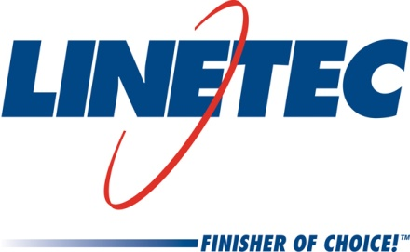
Media contact:
Heather West, 612-724-8760
heather@heatherwestpr.coms

Linetec adds three associates to growing team
Brandon Slowiak as continuous improvement manager, Cody Horne as manufacturing engineer, Tad Klabacha as senior technical engineer

Wausau, Wisconsin (May 2018) – Three new associates have joined Linetec to support the company’s continued growth and its customers’ ongoing need for high-quality, high-performance, finished, architectural aluminum products. Brandon Slowiak started his role as a continuous improvement manager, Cody Horne as a manufacturing engineer and Tad Klabacha as a senior technical engineer.

In his role as continuous improvement manager, Slowiak reports to Linetec’s vice president of operations Andy Joswiak. He is responsible for leading the company’s Lean initiatives and continuous improvement training and activities, inspiring a culture of continuous improvement, and driving results through ongoing process improvements.

Most recently, Slowiak worked as a value stream manager at Parker Hannifin Corporation, a global leader in motion and control technologies. Seven years ago, he began with the company as a process engineer and earned progressively more challenging roles while gaining experience in operations. Certified as a high performance team coach, he has led Lean manufacturing training programs. In addition to his knowledge of Lean, he has a bachelor’s degree in manufacturing engineering with a minor in business administration from the University of Wisconsin-Stout. He currently lives in Wausau.

Horne also is a University of Wisconsin graduate and lives in Wausau. He graduated from Marathon County with an associate’s degree and from Platteville with a bachelor’s degree in mechanical engineering. His professional engineering experience includes positions at Greenheck Fan Corporation, Neenah Paper, Hydratight and most recently, as a product engineer with custom hydraulic cylinder manufacturer JARP Industries, Inc. At Linetec, he will focus on continually and cost-effectively improving the manufacturing process. He reports to Bob Laduron, Linetec’s quality and process improvement manager.

Also reporting to Laduron, Klabacha also will recommend and implement continuous improvements through value-focused manufacturing processes. Drawing from more than a decade of experience in manufacturing, he previously worked at Vista Outdoor’s Federal Cartridge Company as a manufacturing engineering supervisor responsible for managing a 17-person team. He holds several technical certificates including as a Six Sigma Green Belt and for Lean manufacturing. He graduated from the University of St. Thomas in Minnesota with a bachelor’s in mechanical engineering. He relocated from the Twin Cities to the Wausau area.

Learn more about joining Linetec’s growing team of associates by visiting www.linetec.com and clicking “Employment.”

Located in Wisconsin, Linetec serves customers across the country, finishing such products as aluminum windows, wall systems, doors, hardware and other architectural metal components, as well as automotive, marine and manufactured consumer goods. The company is a subsidiary of Apogee Enterprises, Inc. (NASDAQ: APOG).

Linetec is a member of the Aluminum Anodizers Council (AAC), the American Architectural Manufacturers Association (AAMA), the American Institute of Architects (AIA), the Association of Licensed Architects (ALA), the Glass Association of North America (GANA), the U.S. Green Building Council (USGBC) and the Window and Door Manufacturers Association (WDMA).
###

