AIA Expo booth #1143
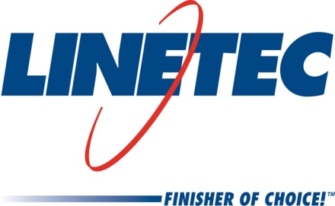
Media contact:
Heather West
612-724-8760
heather@heatherwestpr.com

Linetec announces wood grain finishes

Wausau, Wisconsin (April 2016) – Achieving the look of wood without the maintenance, Linetec has teamed with Decoral System USA to offer new, decorative, wood grain finishes for architectural aluminum products. These finishes are available in a vast variety of different options, colors and species.

The high-quality appearance lends the finishes to interior surfaces, such as for window frames, door panels, column covers, shutters, furnishings and hardware. The coatings’ durable performance also makes them suitable for exterior applications, such as garage doors, fencing and soffits.

“In our industry, we are seeing the use of real wood in applications like curtainwall mullions and interior window surfaces. The Decoral process gives us the ability to offer a similar look at less cost,” said Jon Close, Linetec’s vice president of sales and marketing.

He added, “We see an opportunity for customers to offer the softness and warmth of wood in environments where a hard, cleanable surface is still desired, such as in health care and education facilities, or other high-traffic areas.”

These finishes meet the stringent standards of AAMA 2604-13 for color uniformity, specular gloss, dry film hardness and adhesion, as well as resistance to impact, chemicals, detergents, scratches, corrosion, salt spray and fading due to ultraviolet light. The coatings also are fire retardant, and resistant to water and humidity. Unlike natural wood, the finished aluminum does not swell, rot, warp or attract insects.

Supporting environmentally sound practices, these wood grain finishes utilize a powder coat process that does not emit volatile organic compounds (VOCs). Wood grain finishes can be specified with aluminum utilizing recycled content, and may be recycled after its product lifespan.

In addition to accurately portraying authentic wood grain, the Decoral process can provide customers with marble and stone finishes, floral and camouflage patterns, animal prints or custom logo graphics.

Enrico Piva, CEO of Decoral System USA, agreed and added, “We are proud to have an industry leader like Linetec add Decoral technologies to their new lineup of products and are excited to be a part of their success. We welcome Linetec to the Decoral family and look forward to growing together.”

For more information about Linetec’s finishing services, please call 888-717-1472, email sales@linetec.com or visit http://www.linetec.com.

Located in Wisconsin, Linetec serves customers across the country, finishing such products as aluminum windows, wall systems, doors, hardware and other architectural metal components, as well as automotive, marine and manufactured consumer goods. The company is a subsidiary of Apogee Enterprises, Inc. (NASDAQ: APOG). Linetec is a member of the American Institute of Architects (AIA), the Association of Licensed Architects (ALA), the American Architectural Manufacturers Association (AAMA) and the U.S. Green Building Council (USGBC).
###

