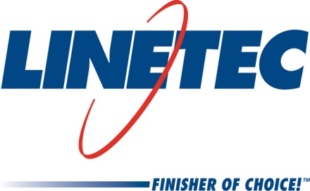
AIA Expo booth #2858
Media contact:
Heather West
612-724-8760, heather@heatherwestpr.com

Stretch Forming by Linetec curves and finishes

architectural aluminum products in one location

Wausau, Wisconsin (March 2015) – Stretch Forming by Linetec allows architectural product manufacturers to have their metal building components curved and finished in one location. Half-circles, eyebrows and Gothic arches are popular architectural applications.

Customers can ship their aluminum to Linetec for bending and finishing to retain the full finish warranty. Utilizing Linetec’s dedicated fleet of trucks saves customers shipping costs and transit time, as well as reduces material handling and packaging to minimize the opportunity for damage.

Linetec’s full scope of bending capabilities includes annealing and tempering to soften and harden aluminum. Born from the aerospace industry, stretch forming maintains precise dimensions throughout a curve. The extrusion is kept under constant tension, while wrapping it around a form, or die. This produces perfectly contoured products, while limiting or even eliminating wrinkling inside the arc.

In addition to stretch forming, Linetec offers a broad choice of paint, anodize and powder coat, plus field repair and restoration, thermal improvement and other support for finished aluminum products. For more information about Stretch Forming by Linetec, finishing and other services, please call 888-717-1472, email sales@linetec.com or visit http://www.linetec.com.

Located in Wisconsin, Linetec serves customers across the country, finishing such products as aluminum windows, wall systems, doors, hardware and other architectural metal components, as well as automotive, marine and manufactured consumer goods. The company is a subsidiary of Apogee Enterprises, Inc. (NASDAQ: APOG). Linetec is a member of the American Institute of Architects (AIA), the American Architectural Manufacturers Association (AAMA) and the U.S. Green Building Council (USGBC).
###

