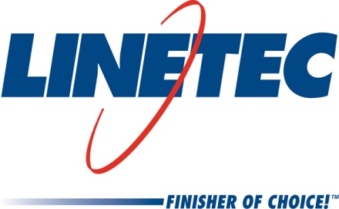
Media contact:
Heather West
612-724-8760
heather@heatherwestpr.com

Linetec offers thermally improved, curved extrusions,
finished and fully warrantied

Wausau, Wisconsin (Feb. 2016) – As one of the largest architectural finishing companies in the U.S., Linetec also is one of the only to provide thermal improvement services for curved and radius, finished aluminum extrusions backed with an industry-leading warranty. Linetec’s new processes offer a full pour-and-debridge of radius material, both structural and non-structural, and a fully crimped thermal strut system. There are no restrictions to the degree of curvature, and finishes may be specified in liquid paint, powder coat or anodize.

Durable finishes, thermal comfort and energy performance can be combined with recycled aluminum content, daylight, views and other environmental benefits for recognition by such green building and design guidelines as the U.S. Green Building System’s LEED® certification.

“Contributing to commercial and residential properties’ energy efficiency goals, high thermal performance has become an expectation when selecting window, skylight, curtainwall, storefront and entrance systems,” observes Linetec’s senior marketing specialist, Tammy Schroeder, LEED Green Associate. “Building owners and architects don’t need to compromise performance for aesthetics if they want a radius instead of a rectangle.”

A thermal barrier system improves performance by separating the aluminum profile into two parts, while maintaining the structural and long-term durability of the unit. The two methods for doing this are pour-and-debridge or thermal strut systems. Linetec follows the stringent industry standards of AAMA QAG-2-12, “Voluntary Quality Assurance Processing Guide for Polyamide Thermal Barriers” and QAG-1-09, “Quality Assurance Processing Guide for Pour and Debridged Polyurethane Thermal Barriers.”

Installing the thermal barrier in the metal after it has been curved helps minimize stress on the thermal barrier and ensures performance as specified. Choosing the thermal strut system provides the additional design flexibility of dual finishing, where the interior and exterior surfaces may be finished in different colors and formulations.

Schroeder cautions, “Regardless of the effect the curving process has on the finish, nearly all manufacturer and applicator warranties are voided when extrusions or brake metal are finished prior to curving. When our customers ship us their aluminum, Linetec alleviates this worry and performs all the services in the proper order and the same place to retain the full finish warranty. Utilizing our dedicated fleet of trucks, we also save customers shipping costs and transit time.”

For more information about Linetec’s thermal improvement, stretch forming and finishing services, please call 888-717-1472, email sales@linetec.com or visit http://www.linetec.com.

Located in Wisconsin, Linetec serves customers across the country, finishing such products as aluminum windows, wall systems, doors, hardware and other architectural metal components, as well as automotive, marine and manufactured consumer goods. The company is a subsidiary of Apogee Enterprises, Inc. (NASDAQ: APOG). Linetec is a member of the American Institute of Architects (AIA), the Association of Licensed Architects (ALA), the American Architectural Manufacturers Association (AAMA) and the U.S. Green Building Council (USGBC).
###

