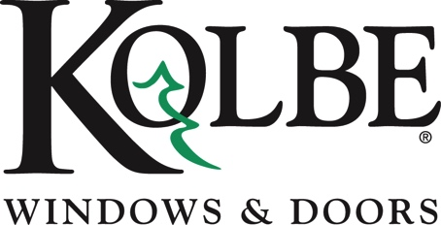

Kolbe will be exhibiting at the NAHB International Builders’ Show in Booth #W3870

Media contacts: Heather West, 612-724-8760, heather@heatherwestpr.com
Cindy Bremer, 715-847-0570, cindy.bremer@kolbewindows.com

Kolbe’s stylish entrance doors make a grand statement
with numerous opportunities for personalization

Wausau, Wisconsin (Jan. 2018) – Kolbe Windows & Doors showcases its entrance doors at the National Association of Home Builders (NAHB) International Builders’ Show in booth #W3870, highlighting design, customization options and finishing touches.

“A grand entrance adds distinction and makes a powerful impression. Our built-to-order entrance doors are designed to your specifications, offering numerous customization options with an expanded hardware selection,” says Cindy Bremer, vice president of marketing at Kolbe Windows & Doors.

Kolbe has partnered with Baldwin® Hardware to offer enhanced door hardware options that embellish any entry and complement every design and aesthetic. This expanded offering adds a mark of distinction to a personalized, custom entryway, with a variety of styles and finishes available.

“Whether you choose a traditional or a contemporary style, our extraordinary entrance doors are designed to your specifications, so no two are alike. Personal marks of distinction include wood species, stain color, shape and size, divided lites, specialty glass, hardware and functionality,” states Bremer. “The decorative Baldwin handles add the finishing touch to highlight your entrance.”

An Ultra Series outswing door invites show attendees into booth #W3870, in a two-wide configuration with sidelites. The exterior is finished in a vibrant Papaya color, with a crisp, Bright White interior. The unit features IPD4 laminated, impact-resistant tempered glass, with 4-1/2-inch performance divided lite bars. Multi-point Baldwin Richland-style hardware in Antique Nickel adds an elegant accent to this eye-catching door.

On the traditional end of the spectrum, a Heritage Series inswing door with sidelites and custom wrap transom displays classic style. The Alder wood exterior and interior are finished with custom stain, while beveled glass and true divided lites in the sidelites elevate the aesthetic. The door’s multi-point hardware is electronically activated with a fingerprint swipe for easy, secure operation, with a München handle set in Rustic Umber.

A Mahogany wood pivot door with a Rockwood® GeoMetek locking pull handle in Satin Stainless finish and energy-efficient, tempered LoE²-270 reeded glass shows Kolbe’s breadth of capabilities. Five feet wide by 9 feet tall, the specialized pivoting hardware allows easy operation in spite of its large size.

“The entrance to your home is an outward expression of your style and personality,” says Bremer. “Kolbe offers numerous options for creating a truly one-of-a-kind entrance that makes a long-lasting impression.”

For complete information and product details on Kolbe’s extraordinary entrance doors, please visit www.kolbewindows.com.

What began in 1946 as a two-brother team has grown into an internationally respected manufacturing company. Kolbe Windows & Doors is one of the nation’s leading manufacturers of windows and doors for residential and commercial markets. After more than 70 years, Kolbe products are best known for superior quality, custom craftsmanship, attention to detail, as well as innovative and unique designs.
###

