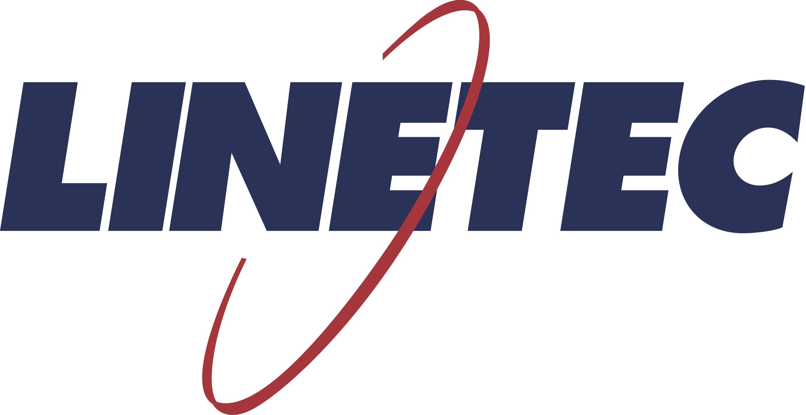
Media contact:
Heather West
612-724-8760
heather@heatherwestpr.com

Linetec helps Tommy’s Express attract attention in Wisconsin with bright red finishes that match its growing national brand

Wausau, Wisconsin (April 2020) – Wisconsin’s first Tommy’s Express Car Wash opened in Weston as part of a strategic, national expansion. A second location is under construction in Wausau. Linetec, based in Wausau, proudly supported this new locally owned business with brand-compliant, bright red, architectural finishes.

“Our colors are at the core of how we present ourselves. The Tommy’s red represents excitement and strength, so our guests always know they are getting not only the most exciting experience, but the most consistent,” said Amy Jensen, regional manager of Tommy’s Express Stratton Car Wash. “Our red also creates more immediate brand awareness in a crowded marketplace. T-Mobile has its magenta. McDonald’s has its yellow. And we have our red and black.”

She explained, “At Tommy’s Express, you and your car take a gentle glide through the wash and in just 3 minutes, your car will be clean, shiny and dry. You can wash once, or for one monthly price, you can wash as often as you’d like by downloading the Tommy’s Express app.”

Each Tommy’s Express is locally owned and operated. In January 2020, the Tommy’s Express franchise operated 29 locations, with more than 70 additional sites slated to open this year in markets across the United States. While the franchise is young, its history is solid: The Michigan-based family of companies behind Tommy’s Express celebrated its 50 year anniversary in 2019.

Compared with traditional car washes, Tommy’s Express notes that it employs custom, state-of-the-art technology to provide car washes that are faster, safer and perform better. Its facilities are designed and built with considerations to reduce energy consumption and water use.

In addition to these sustainable considerations, the Wisconsin franchise relies on Linetec’s environmentally responsible practices and high-performance, durable, low-maintenance architecture coatings. For the Wisconsin locations, Linetec is finishing the exterior metal wall panel systems in 70% PVDF resin-based architectural coatings.

When applying liquid coatings, Linetec safely contains and destroys VOCs before they leave its facility. When the finished aluminum arrives at the jobsite, the material is ready to be installed with no adverse environmental impact. After their useful life on the building envelope, the finished aluminum material can be recycled and re-used.

“These 70% PVDF resin-based coatings are formulated and applied for premium durability in our Wisconsin climate. They stand up to snow, humidity, heat, road salt and more. They shield the aluminum against weathering, pollution and aging, as well intense UV radiation,” explained Linetec’s marketing manager Tammy Schroeder.

“They retain their color and gloss, and resist long-term chalking, protecting the brand image of Tommy’s Express,” she added. “The bold red attracts new customers and provides a visual reinforcement reminding loyal clients to return.”

The breadth of colors offered in these durable coatings make them a popular choice for architects, specifiers and aluminum architectural product manufacturers. Linetec currently offers more than 50,000 colors and its in-house blending laboratory can match or make almost any conceivable color.

Learn more about joining Linetec’s architectural finishes and services by visiting https://linetec.com.

About Linetec
Located in Wisconsin, Linetec serves customers across the country, finishing such products as aluminum windows, wall systems, doors, hardware and other architectural metal components, as well as automotive, marine and manufactured consumer goods. The company is a subsidiary of Apogee Enterprises, Inc. (NASDAQ: APOG).

Linetec is a member of the Aluminum Anodizers Council (AAC), the American Institute of Architects (AIA), the Association of Licensed Architects (ALA), the Fenestration & Glazing Industry Alliance (FGIA), the National Glass Association/Glass Association of North America (NGA/GANA) and the U.S. Green Building Council (USGBC).
###

