For media requests and interviews with Bill Moran:
- English-language media:
Heather West, +1-612-724-8760, heather@heatherwestpr.com;
Robin Smothers, +1-763-370-7347, robin@robinsmothers.com
- Italian-language media: Chiara Agnoli, +06-69879575, c.agnoli@vatlib.it; Cleo Meacci, c.meacci@vatlib.it
- More information online at https://www.letterfish.press/news
- Images and video available at https://files.heatherwestpr.com/index.php/s/p21BhZANHjf3ePw

The Vatican Library selects U.S. artist Bill Moran to create LetterFish artworks for “AQVA. Catastrophe and Wonder”
water-themed exhibit, held Sept. 2026-May 2027 in Rome
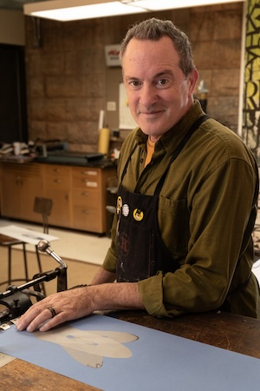
St. Paul, Minn. (Sept. 2026) – The Vatican Library selected world-renowned, Minnesota-based artist, Bill Moran, to create 12 original LetterFish artworks for its water-themed exhibit “AQVA. Catastrophe and Wonder.”

Uniting the past with the present, each LetterFish sea creature’s form is composed of historic type, colorful and metallic inks, and traditional printing methods. Complementing the physical works on display at the Library, Moran also has designed a free, online build-your-own LetterFish game for players everywhere.

Representing a new chapter in the centuries-old mission of conservation and dissemination carried out by the Vatican Library, the exhibit in Rome opens Sept. 15, 2026 and runs on selected dates through May 14, 2027. Pope Leo XIV will visit the Vatican Apostolic Library and inaugurate the exhibition on Sept. 14 at 11 a.m. Central European Summer Time.

Explore Moran’s artwork, influences and insights at LetterFish.press. Learn more about the Vatican Library’s collection, exhibitions, “Agenda” and other publications available for purchase at https://www.vaticanlibrary.va.

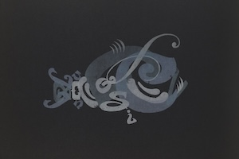
Enduring Inspiration
The first in the Library’s five-year exhibition cycle, “AQVA. Catastrophe and Wonder” explores the perception of water as a threatening force, a path of reconciliation and as a vital resource. It also highlights the Library’s Renaissance-era book, “Aquatillium Animalum Historiae.” Evolving from this book’s realistic fish illustrations, Moran’s modern interpretation imprints the text’s ancient DNA into each LetterFish artwork and celebrates water’s vital connection to all living beings.

“The exhibition ‘AQVA’ also provides an opportunity to celebrate the 470th anniversary of the publication, financed and promoted by the Vatican Library, of the remarkable treatise on fish by the physician Ippolito Salviani, completed in Rome in 1557,” noted Rev. Giacomo Cardinali, vice prefect and commissioner for exhibitions.

(continued)

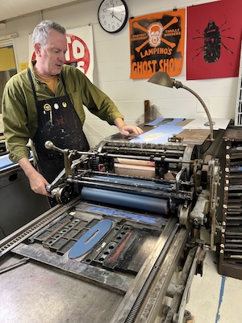
Artistic Origins
Moran is not only an artist, but also a third-generation letterpress printer, a graphic designer, a typographic historian, a professor at the University of Minnesota’s College of Design, and co-founder of TipoItalia’s study-abroad program in Cornuda, Italy. He also served as Hamilton Wood Type & Printing Museum’s artistic director (2009-2021), helping expand the Wisconsin-based museum’s archive and elevate its recognition as the world’s largest collection of wood type.

Born to a Midwestern American, Catholic family, Moran’s connection to Italy and the Vatican began with an appreciation for their ancient artistry and illuminated texts. “I grew up in my family’s Wisconsin print shop, where I first learned to see type not just as language, but as a creative system – something you could build, shape and bring to life,” said Moran.

Before spawning the LetterFish concept, Moran’s playful typographic LetterBugs prints debuted in 1999 at the Saint Paul Art Crawl in Minnesota and have since traveled the globe in exhibitions, collections and archives across the U.S. and Europe. The Vatican Library’s staff and associates saw the LetterBugs prints on view at the Tipoteca Italiana, Italy’s premier museum devoted to Italian printing and type history.

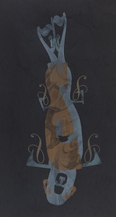
Creative Methods
“The Vatican Library gave me freedom to make whatever fish I wanted,” said Moran. His LetterFish prints are named:
- Nurse Shark
- Koi Fish
- Octopus
- Nouveau Fish
- Whale Shark
- Rainbow Fish
- Diving Fish
- Monk Fish
- Manta Ray
- Letter Shark
- Angler Fish

Along with the printed works, LetterFish take flight in an illuminated sculpture.

All the letterforms used to create the LetterFish artworks for the Library’s “AQVA. Catastrophe and Wonder” exhibit come from the Art Nouveau wood type collection housed by Tipoteca Italiana. The type itself was cut between 1890 and 1930 by a variety of wood type makers throughout Europe. The Library also requested Moran use these ornate typefaces when designing “Agenda 2027 / Agende annuali della Bilioteca Apostolica Vaticana” and includes reproductions of LetterFish artworks.

(continued)

Moran printed the original LetterFish on exhibit in the Library using a Vandercook Model 219 manufactured in 1946 and so-named because of its 19-inch-wide press bed. He acquired it from Augsburg Fortress Publishers in Minneapolis, where it saw daily use for this religious publisher. “Neither the makers of this press nor my grandfather Frank Moran could have envisioned how these machines have lived on into the digital age where the word ‘obsolete’ is applied on a daily basis.”

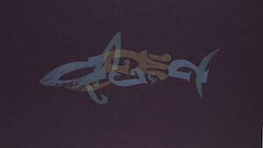
Global Connections
“The starting point of the entire exhibition cycle was Gaetano Volpi’s bibliophilic treatise ‘Del furore d’aver libri’ (1756), which lists the dangers threatening the preservation of books: from water to fire, from light to animals, and even the damage inflicted by human beings themselves on their cultural heritage. In the belief that, in the face of fear, it is wiser to pause and move through it, we enlisted three extraordinarily creative minds – an artist, a typographer and a chef – and discovered unexpected horizons precisely within what usually frightens us,” said Rev. Cardinali.

The exhibition will also feature the French artist JR and the Italian chef Fulvio Pierangelini, each of whom reinterprets the theme and the Library’s historical collections through their own artistic practices. The exhibition is curated by Rev. Cardinali, Simona De Crescenzo, Francesca Giannetto and Delio Proverbio.

“Through decades of studying and teaching typography, I’m thankful not just for the knowledge and inspiration I’ve gained, but also for the connections forged with other artists, printers and cultural institutions around the world,” said Moran. “I feel equally at home in the American Midwest as I feel welcomed in Italy and the Vatican.”

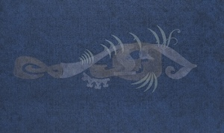
“Catastrophe and Wonder” – A five-year cycle
“The cycle is dedicated to reflecting on natural elements as mirrors of humanity’s fears and hopes. These same elements, which pose one of the greatest threats to the preservation of historical heritage, and thus to collective memory, become a universal allegory of humanity’s deepest anxieties in the face of what lies beyond its control,” explained the librarian and archivist of the Holy Roman Church, H.E. Monsignor Giovanni Cesare Pagazzi.

He continued, “These exhibitions are intended to foster dialogue between contemporary art and the Library’s centuries-old heritage. On several occasions, the Pope has emphasized fidelity to the past and fidelity to the future. The present, including the present of this exhibition, can become the home where past and future meet as friends. Through its own distinctive gestures, the Apostolic Library – the Library of the Apostle, the Library of the Pope – wishes to contribute to the building of this home.”

(continued)

About the Vatican Apostolic Library
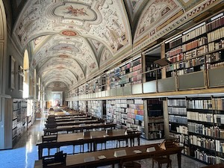
The Vatican Apostolic Library is an ancient institution dedicated to preservation and research, belonging to the Pope and closely connected to the governance and ministry of the Apostolic See.

From the Scrinium, documented as early as the 4th century, the Library began its modern history with Pope Nicholas V, who in the mid-15th century decided to open the papal book collections to scholars (“pro communi doctorum virorum commodo,” Brief of April 30, 1451), and with Pope Sixtus IV, who provided a more stable organizational structure with the Bull “Ad decorem militantis Ecclesiae” of June 15, 1475.

Its vast collections – comprising manuscripts, archival materials, printed volumes both ancient and modern, coins and medals, prints and drawings, as well as cartographic and photographic materials – have always been accessible to qualified scholars from around the world, regardless of race, religion, origin, or culture. The Library specializes primarily in philological and historical disciplines, and, retrospectively, also in theology, law, and the sciences.

***
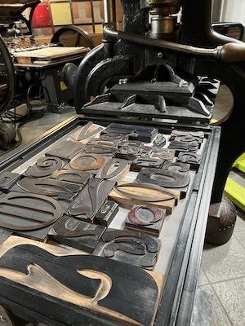
For media requests and interviews with Bill Moran:
- English-language media:
Heather West, +1-612-724-8760, heather@heatherwestpr.com;
Robin Smothers, +1-763-370-7347, robin@robinsmothers.com
- Italian-language media: Chiara Agnoli, +06-69879575, c.agnoli@vatlib.it; Cleo Meacci, c.meacci@vatlib.it
- More information online at https://www.letterfish.press/news and from the Vatican Library
- Images and video available at https://files.heatherwestpr.com/index.php/s/p21BhZANHjf3ePw

For the Sept. 14 media preview and presentation of the new exhibition space:
On Sept. 14 at 8:30 a.m. CEST, accredited journalists and media representatives are invited to attend the press preview of “AQVA. Catastrophe and Wonder” within the Vatican Apostolic Library. At the conclusion of the presentation, attendees will be able to observe the arrival of the Holy Father from the Cortile del Belvedere.
Once accredited by the Holy See Press Office, journalists and media representatives will receive a press note detailing the day’s program and access procedures.

###

