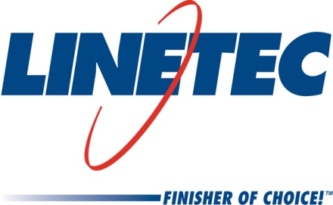
Media contact:
Heather West
612-724-8760, heather@heatherwestpr.com

Linetec’s founder and past president, Scott Platta, retires

Wausau, Wisconsin (July 2015) – Scott Platta celebrated his retirement on June 25, following a 40-year career that includes founding Linetec in 1983 and serving as its first president. Thanks in part to Platta’s vision and leadership, Linetec is now the nation’s largest independent architectural finisher providing paint and anodize finishing services for such products as windows, curtainwall, entrances, hardware and other components.

“I started my career as a part-time kid, low man on the ladder, and worked my way up to president. I was always given the opportunity to improve and advance in the company. Mistakes were tolerated as long as you were focused and your heart was going in the right direction,” Platta remembers. “I feel very fortunate to have worked for a very competent group of managers and associates. Linetec and Apogee Wausau Group is world-class, and a wonderful company to have spent my career.”

When Platta became president, he oversaw 20 employees and a new aluminum-coating facility in Wausau, Wisconsin. Supported with the financial stability of parent company, Apogee Enterprises, Inc., he helped grow Linetec’s business to the 450 plus employees of today. Platta and Linetec’s team achieved this success by helping manufacturers meet architects’ increasing demand for aluminum windows in a wider variety of colorful, durable finishes.

“He was one of the first in the industry who identified the need for fluoropolymer paint,” praises Linetec’s current president, Rick Marshall. “It was Scott’s initial vision to have Linetec be more than just a finishing company. He added value by expanding services for its customers. Among his many ideas that we continue to build upon are our on-site field service, our in-house paint blending laboratory and capabilities, our Linetec Managed Inventory and our Linetec designated route trucks.”

Understanding customer needs came easily to Platta. Prior to joining Linetec, he worked for its first customer Wausau Window and Wall Systems, then known as Wausau Metals. He continued to grow this and other customer relationships at Linetec. Platta was responsible for acquiring the Polywood Shutter painting business, which for many years, was Linetec’s largest customer. He continued to manage Polywood Shutter’s fabrication facility located in Wausau, in partnership with owners Sunburst Shutters of Las Vegas, and served as its liaison with Linetec.

“Scott’s legacy is more than professional success,” emphasized Marshall. “His accomplishments have benefited thousands of people across our community and our industry. And he has done it along with a great sense humor and humility.”

For more information about Linetec’s history of success and finishing services, please visit http://www.linetec.com.

Located in Wisconsin, Linetec serves customers across the country, finishing such products as aluminum windows, wall systems, doors, hardware and other architectural metal components, as well as automotive, marine and manufactured consumer goods. The company is a subsidiary of Apogee Enterprises, Inc. (NASDAQ: APOG). Linetec is a member of the American Institute of Architects (AIA), the Association of Licensed Architects (ALA), the American Architectural Manufacturers Association (AAMA) and the U.S. Green Building Council (USGBC).
###

