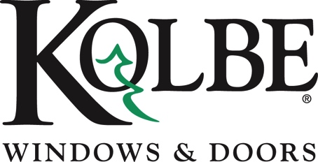

Media contact: Heather West, 612-724-8760, heather@heatherwestpr.com

Kolbe Gallery Twin Cities’ Lance Premeau
joins NARI-MN Board of Directors

Wausau, Wisconsin (Nov. 2022) – Kolbe & Kolbe Millwork Co., Inc. is pleased to announce that Lance Premeau has joined the National Association of the Remodeling Industry (NARI) Minnesota Board of Directors. This association is dedicated to advancing and promoting the remodeling industry through professionalism, programming and education.

As the current general manager of Kolbe Gallery® Twin Cities, Premeau oversees the sales and service professionals as well as the retail operation located in Edina, Minnesota. Kolbe Gallery Twin Cities is the greater Minneapolis/St. Paul area dealer of Kolbe® windows and doors, with a showroom featuring VistaLuxe® Collection, Ultra Series, Heritage Series and Forgent® Series products.

During Premeau’s 30 years of millwork industry experience with Kolbe Windows & Doors, he has worked in various leadership roles, including general manager, business development, market intelligence manager, market and product manager, market analyst, and manufacturing plant manager.

“Lance’s integrity, high standards, unmatched industry experience, and investment in knowledge and enrichment will be true assets to the board as well as other industry professionals,” said Kolbe’s president, Jeff DeLonay.

Premeau also represents Kolbe as an active member of the American Institute of Architects (AIA) Minnesota, the National Association of Home Builders (NAHB) Minnesota chapter, Housing First Minnesota, the Minnesota Chapter of the National Association of the Remodeling Industry (NARI), and the Minneapolis-St. Paul Chapter of the Construction Specification Institute (CSI). Furthermore, he has achieved professional credentials as a U.S. Green Building Council (USGBC) LEED® Green Associate as well as Construction Specifications Institute (CSI®) Construction Documents Technology (CDT®) certification.

Premeau added, “I am honored to be a part of this organization, and am eager to help advance homeowners’ remodeling experience by connecting them with high-quality, dedicated professionals.”

To learn more about NARI-MN, please visit https://www.narimn.org/about-nari/

What began in 1946 as a two-brother team has grown into an internationally respected manufacturing company. Kolbe Windows & Doors is one of the nation’s leading manufacturers of windows and doors for residential and commercial markets. After 75 years, Kolbe products are best known for superior quality, custom craftsmanship, attention to detail, as well as innovative and unique designs.

###

