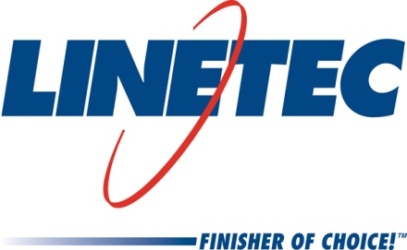
AIA Expo booth #2858
Media contact:
Heather West
612-724-8760, heather@heatherwestpr.com

Linetec adds 10 new hues to faux terra cotta texture colors

Wausau, Wisconsin (March 2015) – Linetec expands its palette of texture finish colors that mimic the look and feel of natural terra cotta to include 10 new hues. The finish utilizes a 70 percent PVDF resin-based coating to achieve the highest levels of performance in an exterior environment and a texture additive to help replicate the natural feel of terra cotta.

Adding to the four colors introduced last year, Linetec’s 14 faux terra cotta colors are:

- Terra Cotta
- Terra Cotta Light
- Terra Cotta Dark
- Terra Cotta Weathered Steel
- Terra Cotta Sage
- Terra Cotta Sage Brown
- Terra Cotta Storm
- Terra Cotta Stormy Monday
- Terra Cotta Slate
- Terra Cotta Slate Gray
- Terra Cotta Sierra
- Terra Cotta Sierra Tan
- Terra Cotta Dark Bronze
- Terra Cotta Black
- Terra Cotta Armagnac
- Terra Cotta Truepenny
- Terra Cotta Copper Mountain

“While no finish can replicate all of the properties and design elements of terra cotta, we are happy to offer customers a cost-effective paint finish that looks and feels like the real thing when applied to architectural aluminum wall panels,” said Jon Close, Linetec’s vice president of sales and marketing.

“In addition, architects like that our faux terra cotta texture colors can be specified on a large variety of shapes and sizes, and on panels manufactured with recycled aluminum content. Compared with true terra cotta, our customers also save time and labor compared to waiting for European shipments and for the heavy, fragile material to be installed on site,” added Close.

As a 70 percent polyvinylidene fluoride (PVDF) resin-based coating, Linetec’s terra cotta painted finish meets the requirements of the American Architectural Manufacturers Association’s most stringent, high-performance specification standard, AAMA 2605-13. These architectural finishes are tested to exhibit outstanding resistance to humidity, color change, chalk, gloss loss and chemicals.

As an environmentally responsible finisher, Linetec safely captures and destroys the volatile organic compounds (VOCs) present in liquid paints at the factory before arrival on the building site. These industry-leading practices complement other green building choices and ensure a long-lasting, durable and sustainable finish.

For more information about Linetec’s expanded palette of faux terra cotta texture colors and other finishing services, please call 888-717-1472, email sales@linetec.com or visit http://www.linetec.com.

Located in Wisconsin, Linetec serves customers across the country, finishing such products as aluminum windows, wall systems, doors, hardware and other architectural metal components, as well as automotive, marine and manufactured consumer goods. The company is a subsidiary of Apogee Enterprises, Inc. (NASDAQ: APOG). Linetec is a member of the American Institute of Architects (AIA), the American Architectural Manufacturers Association (AAMA) and the U.S. Green Building Council (USGBC).
###

