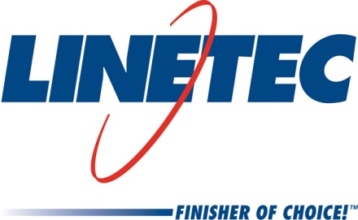
Media contact:
Heather West
612-724-8760
heather@heatherwestpr.com

Linetec expands full-service, finished flat sheet program

Wausau, Wisconsin (March 2016) -- Linetec offers a full-service program for flat sheet aluminum in any quantity and in any choice of anodize finish or paint color, including custom matches, micas and metallics. The program has expanded to include more than 20 stock sizes, with the ability to order nearly any size and thickness. Linetec also can provide fabrication for small- to medium-size brake metal projects, in conjunction with finishing and transportation.

Orders for less than 25 sheets, finished in any of 30,000 in-house blendable paint colors or anodize coatings, Linetec offers a quick-ship program. Quick-ship requests typically are shipped within five days from order confirmation.

Whether choosing finishes for flat sheet or aluminum extrusions, Linetec’s online Select & Spec Tool assists customers in finding their projects’ ideal colors. Visitors to Linetec.com click on the link to the tool, where they may choose from the color palettes with interactive “chips.” Clicking on a chip, the user can see a larger image and immediately order up to five samples. These 3.5-by-2-inch painted metal samples are mailed to the contact information provided by the user. Each sample is labeled with an “LT” paint code for reference when specifying the finish for future architectural projects.

For more information about Linetec’s finishing services, please call 888-717-1472, email sales@linetec.com or visit http://www.linetec.com.

Located in Wisconsin, Linetec serves customers across the country, finishing such products as aluminum windows, wall systems, doors, hardware and other architectural metal components, as well as automotive, marine and manufactured consumer goods. The company is a subsidiary of Apogee Enterprises, Inc. (NASDAQ: APOG). Linetec is a member of the American Institute of Architects (AIA), the Association of Licensed Architects (ALA), the American Architectural Manufacturers Association (AAMA) and the U.S. Green Building Council (USGBC).
###

